Bats in the Belfry?

12 carillon concert tours of Europe and 36 of the USA: who needs anymore? And then the Perpignan carillon festival made me an offer I couldn’t refuse.

So, Bruges, Belgium, that legendary (1610) magnificent old carillon: two concerts at 11 AM and 9 PM, 365 steps each time, with tourists gawking in the doorway of the playing room, and cameras flashing, they climbed all these steps too, I gave them their money’s worth even if a little jet-lagged.

Next day, on the train to Almeera, Netherland’s newest city… 20 years ago this was all under water: a light, bright, sparkling brand new little carillon and amazingly, two people I’d worked with in 1965 in Greenwich, CT showed up and we caught up on 50 years or so…

And the next day, Venlo, Netherlands, where I’d played some years ago, a medium-size instrument very similar to Middlebury’s and a view from the tower of much of Eastern Netherlands and Germany across the river, and a section of town called “der Deutsche Ecke” where everyone speaks… you guessed it.

The next week I spent in a B&B in Tienen, Belgium, which permitted me to travel around and hear other carillons, go to meetings, practice, and do three concerts in the area. One was in Deinze, where, after my concert, I watched in amazement as a nine-year old girl played a classic carillon piece that my Middlebury students struggle with… I thought, “the future is in good hands”, at least the carillon future. Deinze also has a music academy with almost 2,000 students. More good hands.

After that, a quick trip to the Netherlands to Brielle, a picturesque old town, with three marinas and a mighty carillon that invites you to play mightily (I did).

And then five concerts in Germany: first, the Henriettastiftung in Hannover, an enclosed square city block with a carillon in a beautiful enclosed garden. Next, the Marktkirke in Wiesbaden where I heard a concert by an amazing boy choir that actually eclipsed the Stuttgart choir that visited Middlebury earlier this summer.

Something else happened in Wiesbaden that was a little too exciting: while I was practicing on the 125-rank organ (by comparison, St. Stephen’s has 16 ranks and the college organ has 46), during a thunderstorm, lightening struck the other end of the church. Immediately the organ gave an incredible thunderous roar as every single pipe sounded at once… the lightening had fried the control circuits! Hans Hielscher, the cathedral organist, frantically called the organ technicians and it appeared that I had ruined a $4 million organ. I didn’t sleep that night. But the next day the organ men told us that it made no difference whether any one was playing or whether the instrument was even turned on, and that they could repair the damage in about three weeks. The church has a veritable forest of lightening arrestors but they didn’t do their job: several computers were destroyed and there was other damage.

The next few concerts passed in a blur… Bonn (where I visited Beethoven’s house), Kassel, Wuerzburg, one more trip to the Netherlands (Enkhuizen, a beautiful coastal town with literally thousands of boats and the finest carillon I played on my entire trip) and then on to Switzerland and France. Taninges, France, has a unique tower. Six levels contain a collection of about 30 reed organs, the 7th level contains the carillon clavier with bleachers like a sports stadium for people to watch and the 8th level the carillon. It’s pretty loud and they have to climb the 150 steps just like the carillonneur but they love it.

Finally, Perpignan: the oldest and most powerful carillon in South France, atop an awesome sanctuary (in the old sense of the word). You walk into that cathedral and you just don’t feel like saying anything. No one else does either. In Perpignan, a docent announces and describes all the pieces played via a good-quality PA system and there is also a closed-circuit TV, so people can watch the carillonneur pounding away.

And the rest is packing baggage and jet lag. The weeds in the backyard are downright beautiful. And the whistle of the 7 AM freight rumbling through Brandon is sweet music…

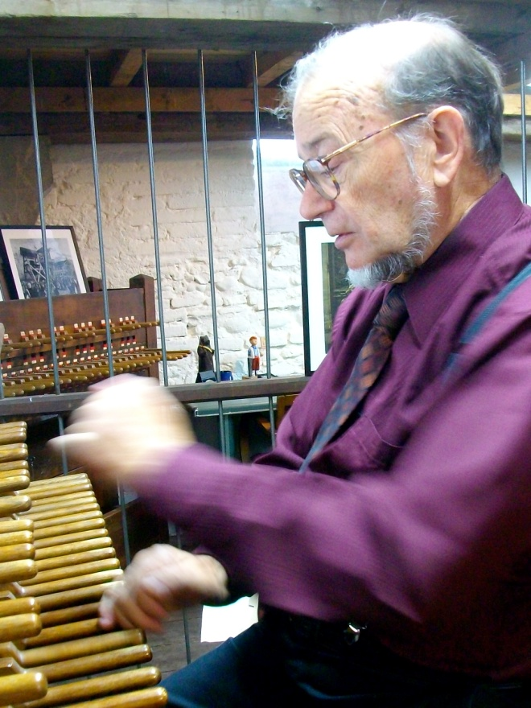
George playing carillon at Perpignan

