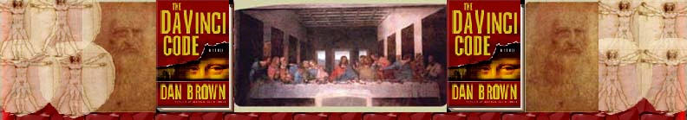Chapter 79
Jay Dolan

Perrier
PTS Team
Chateau Villette
Mélange
Corpulent
Cinquefoil
Jean de Gisors
Marie de Saint-Clair
Guillaume de Gisors
Edouard de Bar
Jeanne de Bar
Jean de Saint Clair

Blance D’Evreux
Nicolas Flamel
Rene D’Anjou
Iolande de Bar
Sandro Botticelli
Leonardo da Vinci
Connetable de Bourbon
Ferdinand de Gonzaque
Louis de Nevers
Roert Fludd
J. Valentin Andrea
Robert Boyle
Isaac Newton
Charles Radclyffe
Charles de Lorraine
Maximillian de Lorraine
Charles Nodier
Victor Hugo
Claude Debussy
Jean Cocteau
Timbre
Rolex

Perrier Perrier is a brand of natural sparkling mineral water that has been around since 1793. It first appeared in Vergeze, France but it has become an international product. It was first introduced to the United States in 1976. Pierre remains one of the leading sellers in natural spring water worldwide.
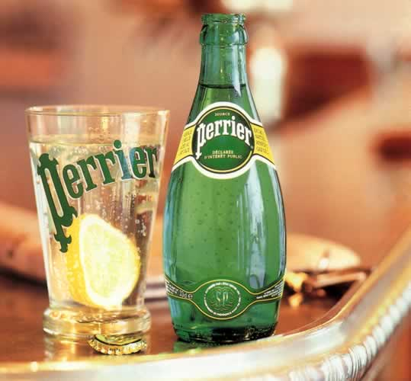
http://www.usa.perrier.com/pressroom/factsheet.asp
http://www.intrat.cz/images/graphics_perrier_intro.jpg

PTS Team- See Chapter 6

Chateau Villette This may have been the Chateau that Brown was talking about because the Chateau de Villette is located 35 minutes outside of Paris. It was designed in 1668 by Francois Mansart and completed in 1696. It has eleven bedrooms and eleven bathrooms. It was first built for Jean Dyel, Louis XIV’s ambassador to Venice.
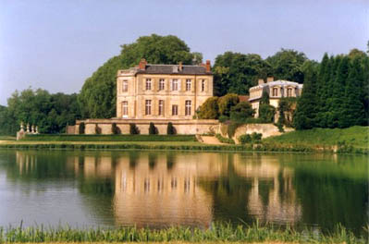
http://www.chateauxandcountry.com/chateaux/villette/index.html

Mélange French for “Mix” http://ets.freetranslation.com/

Corpulent “Of the nature of a physical or material body: solid, dense, gross.”
“Large or bulky of body; fleshy, fat.”
http://dictionary.oed.com/cgi/entry/00050655?single=1&query_type=word&queryword=Corpulent&edition=2e&first=1&max_to_show=10

Cinquefoil “The plant Potentilla reptans (family Rosaceæ), with compound leaves each of five leaflets. Also used of other species with similar leaves, and as a book-name for the whole genus.” “An ornamental design resembling the leaf of cinque-foil.”

http://plants.montara.com/ListPages/thumbs1/pothic0.JPEG
http://dictionary.oed.com/cgi/entry/00040034?single=1&query_type=word&queryword=Cinquefoil&edition=2e&first=1&max_to_show=10

Jean de Gisors Supposedly the first grandmaster of the Priory of Sion, he was a lord in the castle of Gisors located in Normandy. He was the grandmaster from 1188-1220.
http://encyclopedia.thefreedictionary.com/Jean%20de%20Gisors

Marie de Saint-Clair (1220-1266) “She was descended from Henry de Saint-Clair, Baron of Rosslyn in Scotland, who accompanied Godfroi de Bouillon on the First Crusade. Marie’s grandmother married into the French Chaumont family. She was the second grandmaster of the Priory of Sion.” (John V. D’Agostini)

Guillaume de Gisors (1266-1307) “Guillame de Guisor was the Son of Hugues III de Gisors and the grandson of Jean De Gisors. The Prieure documents state that his sister married Jean des Plantard which is one of the supposed relations to Pierre Plantard. Also he is said to be a member of the Order of the Ship and the Double Crescent which was started by King Louis IX.” (John V. D’Agostini)

Edouard de Bar (1307-1336) “He is the grandson of King Edward I, or Longshanks as he is known. He was the Count of Bar and the fourth headmaster of the Priory of Sion.” (John V. D’Agostini)

Jeanne de Bar (1336-1351) “She was the granddaughter of King Edward I and sister of Edouard de Bar. She became the 5th Priory master after the death of her brother.” (John V. D’Agostini)

Jean de Saint Clair (1351-1366) “He was the 16th grandmaster of the Priory.” (John V. D’Agostini)

Blance D’Evreux- (1336- 1398) “She was the granddaughter of King Louis X of France ‘the Stubborn.’ She was the 7th grand master of the Priory of Sion.” (John V. D’Agostini)

Nicolas Flamel- He was a French alchemist. Most of his accomplishments are considered legend but he supposedly succeeded in the two magical goals of alchemy. He created the Philosopher’s stone which turned lead into gold and his wife achieved immortality. As said before, his life is mostly based on legend.
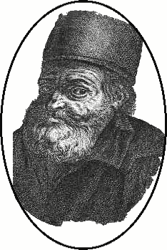
http://en.wikipedia.org/wiki/Nicolas_Flamel

Rene D’Anjou (1418-1480) He was related to the king of France by marriage and is believed to be a descendant of the Davidic bloodline. He was once known as one of the most powerful men in Europe but his Italian campaign failed and he became nothing more than an influence on the renaissance movement. He is known as the 19th grandmaster of the Priory.” (John V. D’Agostini)

Iolande de Bar (1480-1483) “Daughter of René d'Anjou. In 1445 she was married to Ferri, lord of Sion-Vaudémont - which, under her auspices, was extended from a local pilgrimage centre to a sacred site for the whole of Lorraine. During the Merovingian epoch a statue of the Virgin had been erected there and in 1070 the ruling count had publicly proclaimed himself 'vassal of the Queen of Heaven'. The Virgin of Sion was officially declared 'Sovereign of the Comté of Vaudémont', festivals were held in her honor every May and she was acknowledged Protectress of all Lorraine. She was also the 20th grandmaster of the Priory.” (John V. D’Agostini)

Sandro Botticelli See Chapter 23.

Leonardo da Vinci See Chapter 11

Connetable de Bourbon (1519-1527) “Member of the House of Bourbon which was related to the third French Royal lineage known as the Capets. He became famous as a constable of France. He later committed treason against France and had all his land forfeited. He was the 23rd grandmaster of the Priory.” (John V. D’Agostini)

Ferdinand de Gonzaque (1527-1566) “He was the 24th grandmaster of the Priory.” (John V. D’Agostini)

Louis de Nevers- (1575-1595) “He was the count of Flanders and of Nevers and of Réthel. who sided with the French against the English in the opening years of the Hundred Years' War. Grandson and heir of Robert of Bethune, count of Flanders, Louis was brought up at the French court and married Margaret of France. He was the 27th grandmaster.” (John V. D’Agostini)

Roert Fludd (1574-1637) He was a famous English Rosicrucian. He also was active with physics, astrology, and mystics. He was the son of a high ranking government official named Sir Thomas Fludd. He exchanged views with Johannes Kepler about “scientific and hermetic approaches to knowledge.” Fludd was particularly interested in perpetual motion. In 1630 he proposed many perpetual motion machines. One of his machines used a water wheel which pumped water back into its own supply tanks. However, this did not work because the water would reach equilibrium.
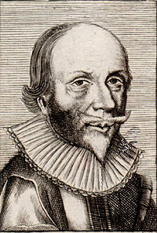
http://www.sil.si.edu/digitalcollections/hst/scientific-identity/thumbnails/TNSIL14-F003-05.jpg
http://en.wikipedia.org/wiki/Robert_Fludd

J. Valentin Andrea (1637- 1654) “Great author that produced many works that have been said to start the Rosicrucian legend. He was also preacher that strived for Church reform. His works major works alchemy and theology are Fama Fraternities and the Confessio. He was also the 29th grandmaster of the Priory of Sion.” (John V. D’Agostini)

Robert Boyle (1627-1691) He was a philosopher and theological writer. He was from Great Britain. He was most famous for his endeavors in chemistry; however, he studied other sciences such as hydrostatics, physics, and medicines. He also founded the Royal Society in 1660 which is the oldest scientific society in Europe. He is most well-known for Boyle’s Law which explains the relationship of the pressure of gas according to its volume. He expressed this in the equation pv=k where p is pressure and v is volume. K is the compression and expansion of a gas at constant temperature.
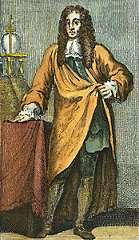
http://search.eb.com/eb/article?tocId=9016072

Isaac Newton See Chapter 23.

Charles Radclyffe He was the fifth Earl of Derwentwater and an early Scottish Freemason. He supposedly served as Grandmaster of the Priory of Sion from 1727-1746. His family ardently followed the Stuarts and therefore joined the Stuart rising of 1715. Charles and James Radclyffe were brothers and were both captured by Preston during the Stuart Rising. There, they were tried for treason and condemned to death. James was beheaded but Charles escaped and rejoined the Stuarts in France. In 1725 Charles founded the first Scottish Rite Masonic lodge. In 1745 Charles was re-captured by English forces and was beheaded on December 8, 1746. http://encyclopedia.thefreedictionary.com/Charles%20Radclyffe

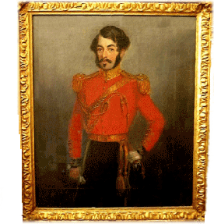
www.don.ratcliff.net/ tree/gallery.htm

Charles de Lorraine He was an Austrian general during the Seven Years War. He was a cautious and careful strategist which caused him to lose many opportunities. He supposedly served as grandmaster for the Priory of Sion from 1746 until his death in 1780. his last major battle was the Battle of Prague in 1757. After being defeated in the battle of Kolin, he was replaced by Leopold von Daun.
http://www.rickard.karoo.net/articles/people_charlesoflorraine.html

Maximillian de Lorraine (1780-1801) “He was the 34th grandmaster of the Priory.” (John V. D’Agostini)

Charles Nodier (1780-1844) He was a French writer who had was well known for his profound effect on the French Romantic movement, but not through his writings. He admired Shakespeare and Goethe. He also encouraged, “French Romantics to look abroad for inspiration.” His most well known writings were his short stories. He is also rumored to have been grandmaster of the Priory of Sion from 1801-1844.
http://search.eb.com/eb/article?tocId=9056027&query=Charles%20Nodier&ct=
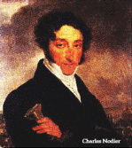
http://www.aei.ca/~anbou/nodier.gif

Victor Hugo See Chapter 61.

Claude Debussy See Chapter 20.

Jean Cocteau See Chapter 48.

Timbre “The character or quality of a musical or vocal sound (distinct from its pitch and intensity) depending upon the particular voice or instrument producing it, and distinguishing it from sounds proceeding from other sources; caused by the proportion in which the fundamental tone is combined with the harmonics or overtones.”
http://dictionary.oed.com/cgi/entry/00252869?query_type=word&queryword=Timbre&edition=2e&first=1&max_to_show=10&sort_type=alpha&search_id=sado-ah2wLz-2929&result_place=1

Rolex In 1905 Hans Wilsdorf founded Rolex; however, it was not known by that name until 1908. That year it was one of the leading watch companies in the United Kingdom. In 1926, Rolex created the first waterproof watch called the Oyster which was used by Mercedes Gleitze to cross the English Channel in 1927. Rolex remains one of the premier watch companies of the world.nhttp://www.watches.co.uk/rolex.html

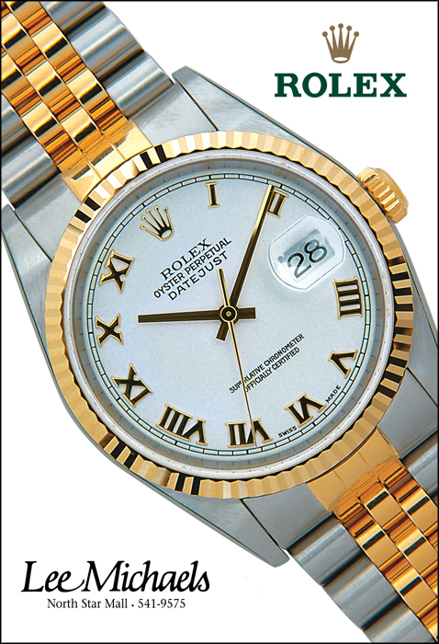
http://www.tkovisual.com/Customers/LM%20Rolex.jpg

