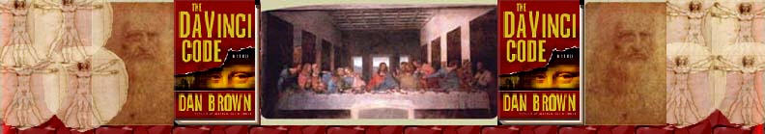Chapter 61
Alexandra Widas
Jay Dolan and Rachel Sleeman

Chauvel
Plantard
Saint-Clair
Da Vinci
Botticelli
Poussin
Bernini
Mozart
Victor Hugo
Legend of Sir Gawain and the Green Knight
Legend of King Arthur
Story of Sleeping Beauty
Masonic symbolism and Grail secrets in Hunchback of Notre Dame (Victor Hugo)
and Magic Flute (Mozart)
Mickey Mouse watch
Walt Disney’s life work was passing on the Grail Story?
Cinderella, Sleeping Beauty, Snow White, Little Mermaid as dealing with the incarceration of the sacred feminine
Sleeping Beauty’s Princess Aurora – code-named “Rose” – as the Grail
DVD
Is SEX really over Simba’s head in The Lion King?
The Little Mermaid – is there actually the painting The Penitent Magdalene in her grotto?
Georges de la Tour
The Penitent Magdalene
Isis
Eve
Pisces the fish goddess
Mary Magdalene
The Book of Isaiah
Meaning of “Ariel”

Chauvel “Marie Chauvel, Sophie Neveu's grandmother, is named for an actual historical figure, Marie Chauvel de Chauvigny, a bishop and head of the Église Gnostique Apostolique , the French Church of Gnostic Apostles.” (http://www.davincilegacy.com/Infringement/private/PerdueBrown-The-heroines-are-the-Goddess.html) No other information could be found to corroborate or dismiss Dan Brown’s claims about the Chauvel family.

Plantard Dan Brown claims that Plantard is the last name of the hidden Merovingian descendents – descended from Mary Magdalene and Jesus Christ. Plantard is also the last name of Pierre Athanase Marie Plantard, born in 1920 in Paris. A government report about Pierre Plantard states, “Plantard, who boasts of having links with numerous politicians, seems to be one of those dotty, pretentious young men who run more or less fictitious groups in an effort to look important and who are taking advantage of the present trend towards taking a greater interest in young people in order to attract the Government's attention.” (http://priory-of-sion.com/psp/id84.html) By 1964 Plantard was claiming that he was a direct descendent of the Dagobert II, a Merovingian king. In fact, he was descended from a 16th century peasant who picked walnuts. Pierre Plantard also revived the Priory of Sion, and the central purpose of the revival was to back his claim as a Merovingian descendant. He created false parchments, gravestones, and genealogies to further this fabrication. During the process of a separate judicial investigation, Plantard was examined on the stand, and admitted under oath that he had made up everything relating to the Priory of Sion. Hence, Dan Brown’s usage of the name Plantard as a descendent from the Merovingians and thus from Jesus simply buys into Plantard’s fraudulent claims. For more information and more links, go here:
http://priory-of-sion.com/psp/id84.html

Saint-Clair No information could be found to corroborate or dismiss Dan Brown’s claims about the Saint-Clair family.

Leonardo Da Vinci See Prologue.

Botticelli See Chapter 23.

Nicolas Poussin See Chapter 3.

Bernini Dan Brown mentions Bernini in passing, including him in a list of great artists whose works whispered of the sacred feminine. While it is reasonable to conclude that he meant the more famous Gian Lorenzo, he could have meant his father, Pietro. Neither are explicitly linked to the sacred feminine, thus both are included here.

Pietro Bernini (1526 – 1629) Pietro Bernini, father of Gian Lorenzo Bernini, was an acclaimed sculptor in Naples and Rome in the late 16th century. In Naples, his works included “Charity in the Church of Monte di Pietà, St. Matthew in the Church of Gesù Nuovo, and the Virgin in the National Museum of San Martino (reworked by Cosimo Fanzago). He also carved the Medina Fountain in San Martino, and the Barcaccia (1627–29), a fountain in the form of a leaking boat in the Piazza di Spagna, Rome, is believed to be his work” (http://search.eb.com/eb/article?tocId=9078860&query=bernini&ct=). For more information and more paintings, follow this link:
http://search.eb.com/eb/topic?idxStructId=62547&typeId=17
Two examples of his sculpture: The Assumption (left) and St. John the Baptist (right).

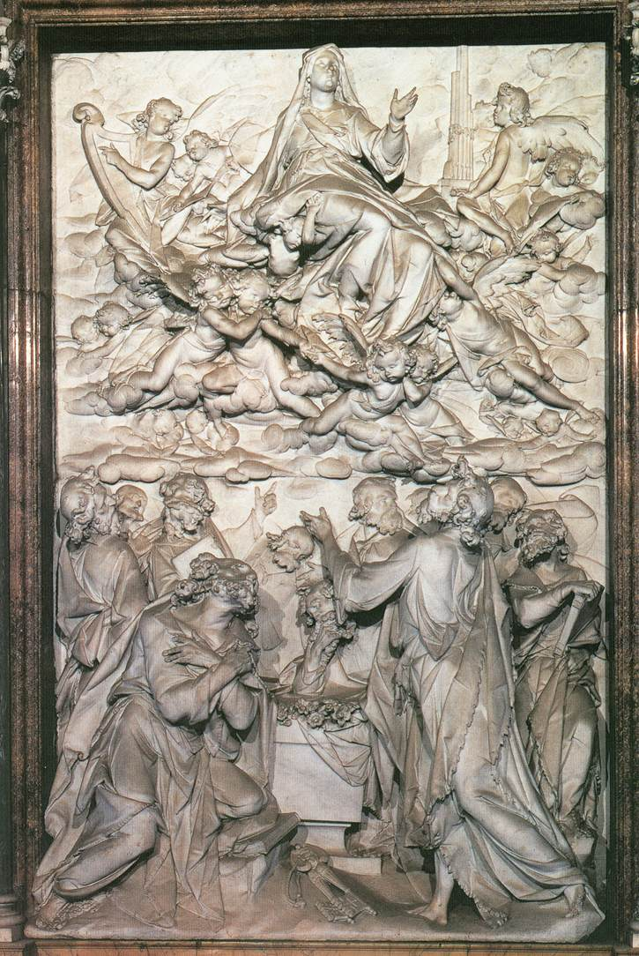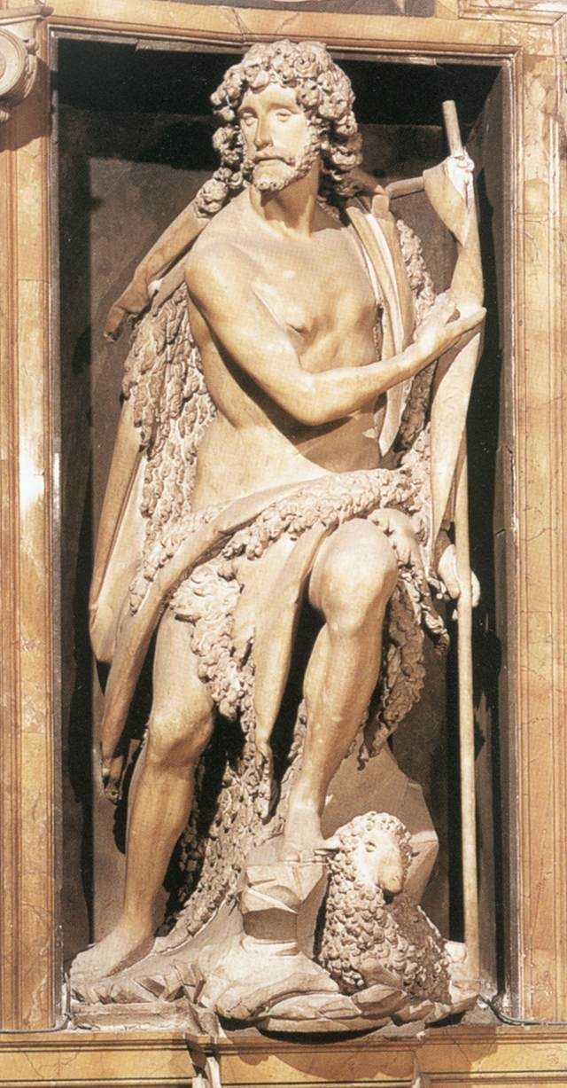

(http://www.wga.hu/frames-e.html?/html/b/bernini/pietro/index.html)

Gian Lorenzo Bernini (1598-1680) Gian Lorenzo Bernini was arguably the greatest sculptor of the 17th century. He “created the Baroque style of sculpture and developed it to such an extent that other artists are of only minor importance in a discussion of that style” (http://search.eb.com/eb/article?tocId=9078859). He also worked as a good architect. Some of his architectural works are the symmetrical curved colonnades of St. Peter's, the facade of Barberini's palace, and the arsenal at Civita Vecchia. Late in his career Bernini designed a series of three churches, culminating in the domed Sant' Andrea al Quirinale, 1658-70, in Rome. At the time of Bernini’s death, his contemporaries considered him to be both “Europe’s greatest artist”, and also one of the greatest men. “He was the last of Italy's remarkable series of universal geniuses, and the Baroque style he helped create was the last Italian style to become an international standard. His death marked the end of Italy's artistic hegemony in Europe” (http://search.eb.com/eb/article?tocId=8225).
For further information and more paintings, follow these links: http://www.boglewood.com/cornaro/xbernini.html
http://www.latein-pagina.de/pics/referate/bernini/bernini.jpeg
digilander.libero.it/.../ bernini/page_01.htm

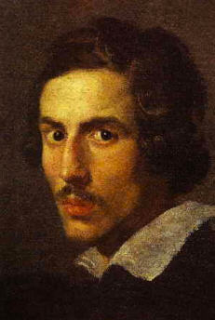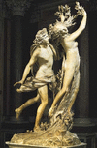

Gian Lorenzo Bernini Apollo and Daphne
http://search.eb.com/eb/topic?idxStructId=62547&typeId=17

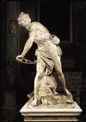

Mozart Full name Johann Chrysostom Wolfgang Amadeus Mozart, baptized as Johannes Chrysostomus Wolfgangus Theophilus Mozart (1756-1791) Wolfgang Amadeus Mozart was one of the greatest composers of Western music. He brought the Viennese Classical School to its peak. He truly stands out from his contemporaries, such as Haydn and Beethoven, in that he wrote in “all the musical genres of his day and excelled in every one. His taste, his command of form, and his range of expression entitle him to be considered the most universal of all composers” (http://search.eb.com/eb/article?tocId=9108745&query=mozart&ct=). He was truly a prodigy, and performed for the Imperial Court at Vienna for the first time at the age of six. “Mozart became a Freemason while staying in Vienna (around 1784), and it was his masonic friends who helped to support him financially. Freemasonry was also an influence on him musically, and he incorporated masonic symbolism into some of his works of this period” (http://www.mfiles.co.uk/Composers/Wolfgang-Amadeus-Mozart.htm). He was buried in an unmarked grave, and the location is still unknown.
http://w3.rz-berlin.mpg.de/cmp/mozart.html For further information and more music, follow these links: http://search.eb.com/eb/article?tocId=9108745&query=mozart&ct=
http://www.mfiles.co.uk/Composers/Wolfgang-Amadeus-Mozart.htm

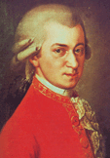

(http://www.mfiles.co.uk/Composers/Wolfgang-Amadeus-Mozart.htm)

Victor Hugo See Chapter 19.

Legend of Sir Gawain and the Green Knight The legend of Sir Gawain and the Green Knight stems from a Middle English poem from the late 14th century, by an unknown author (referred to as the Pearl Poet). The 2500 “alliterative lines” are constructed into irregular stanzas, broken up by short rhyming passages. “It is a chivalric romance that tells a tale of enchantment in an Arthurian setting. Its hero, Sir Gawayne (Gawain), is presented as a devout but humanly imperfect Christian who wins a test of arms, resists temptation by a lord's wife, but succumbs to an offer of invulnerability” (Encyclopedia Britannica). The story “begins at King Arthur’s court at Camelot on New Year’s day. As Arthur's court is feasting, a stranger, the gigantic Green Knight, on horseback and armed with an axe, enters the hall and lays down a challenge. One of Arthur's knights may take the axe and strike a single blow against the Green Knight, on the condition that the Green Knight, if he survives, will return the blow one year and one day later. Sir Gawain, the youngest of Arthur's knights, accepts the challenge and chops off the giant's head. The Green Knight, still alive, picks up his own head, reminds Gawain to meet him at the Green Chapel in a year and a day, and rides off. Almost a year later, Sir Gawain sets off in his finest armour, on his horse Gringalet, to find the Green Chapel and complete his bargain with the Green Knight….The journey takes him from the isle of Anglesey to a castle somewhere in the West Midlands. Gawain meets the lord of the castle and his beautiful wife, who tell him that the Green Chapel is close by, and suggest that he stay with them. The lord, before setting off on a day's hunting, offers a deal to Sir Gawain. The lord will give Gawain whatever he catches, on condition that Gawain gives to the lord, without explanation, whatever he might gain during the day. Gawain accepts. That night, while the lord is still away, the lady of the castle visits Gawain's room and tries to seduce him, claiming that she knows of the reputation of Arthur's knights as great lovers. Gawain, however, keeps to his promise to remain chaste until his mission to the Green Chapel is complete, and yields nothing but a single kiss. When the lord returns with the deer he has killed, he hands it straight to Sir Gawain, as agreed, and Gawain responds by returning the lady's kiss to the lord. According to the lord's bargain, Gawain refuses to explain where he won the kiss. On his second night, Gawain again receives a visit from the lady, and again politely refuses her advances. Next day, when the lord returns, there is a similar exchange of a hunted boar for two kisses.On his third night, when the lady visits his chamber, Gawain maintains his chastity but accepts a silk girdle, which is supposed to keep him from harm, as a parting gift. The next day, the lord returns with a fox, which he exchanges with Gawain for three kisses. The next day, Gawain leaves for the Green Chapel, with the lady's silk girdle hidden under his armour, and accompanied by a guide from the lord's castle. Leaving the guide, who is afraid to approach the Green Chapel, Gawain finds the Green Knight busy whetting the blade of an axe in readiness for the fight. As arranged, the Green Knight attempts to behead Gawain, but after three attempts Gawain remains only slightly injured, the third blow barely cutting his neck. The Green Knight then reveals himself to be an alter ego of the lord of the castle, Bertilak de Hautdesert, and explains that the three axe blows were for the three occasions when Gawain was visited by the lady. The third blow, which drew blood, was a punishment for Gawain's acceptance of the silk girdle. The Green Knight explains that Gawain's trial was arranged by Morgan le Fay, mistress of the wizard Merlin and now a guest at Hautdesert castle. The two men part on cordial terms, Gawain returning to Camelot. There, Sir Gawain recounts his adventure to Arthur and explains his shame at having partially succumbed to the lady's attempts, if only in his mind. Arthur refuses to blame Gawain and decrees that all his knights should henceforth wear a green sash in recognition of Gawain's courage and honour” (http://en.wikipedia.org/wiki/Sir_Gawain_and_the_Green_Knight).
Interestingly, the pentangle is a prominent symbol in the Legend of Sir Gawain. Sir Gawain sets out with a pentacle upon his shield suggests that his knightly virtues are a necessary protection in his quest. “Gawain's five five-fold virtues combine to make him a powerful, perfectly balanced knight, like the pentangle he strives to deserve. Ever alert, he is ``faultless in his five senses” (http://the.rubberpaw.com/writings/gawainsu.html) To read more on the pentangle’s prominence in the Legend of Sir Gawain, follow the above link. “Sir Gawayne and the Grene Knight." Encyclopædia Britannica. 2004. Encyclopædia Britannica Online. 1 Nov. 2004 <http://search.eb.com/eb/article?tocId=9067978>.
Learn more about this legend at: http://www.sparknotes.com/lit/gawain/, 1 Nov. 2004
Read the poem, containing this legend at: http://alliteration.net/Pearl.htm 1 Nov. 2004

Legend of King Arthur The earliest mention of Arthur occurs in very ancient Welsh stories, ‘Historia Britonum' written by Nennius, about two centuries after Arthur’s death. These were tales that Welsh apprentice storytellers were required to learn and make part of their act. King Arthur embodied the pure virtues of knighthood. King Arthur was the son to Uther Pendragon. Upon his birth, Arthur was taken by Merlin to Sir Hector, who then brought up the child as his own. When King Uther died, it was declared that whoever could free the magic sword from the stone gained right to the throne. Arthur freed the magic sword, named Excalibur, and took his place as king. (The Disney Movie, The Sword in the Stone is based upon this portion of the legend). King Arthur married Guinevere and held his court at Camelot. He gathered together the bravest of knights. They all sat as equals about a great round table, as members of the Order of the Round Table. The story of Sir Arthur has constantly been intertwined with the legend of the Holy Grail. "Arthurian legend." Britannica Student Encyclopedia. 2004. Encyclopædia Britannica Online.
1 Nov. 2004 <http://search.eb.com/ebi/article?tocId=9272966>. For more information, visit: http://www.legends.dm.net/kingarthur/ 1 Nov. 2004.

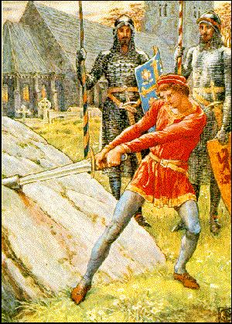
King Arthur pulling Excalibur from the stone http://www.uidaho.edu/student_orgs/arthurian_legend/gallery/c_img/c_adss.jpg,

Sleeping Beauty Once upon a time, a Queen had a beautiful baby daughter. She asked all the fairies in the kingdom to the christening, but unfortunately forgot to invite one of them, who was a bit of a witch as well. She came anyway, but as she passed the baby's cradle, she cursed the baby. She said that when the Princess was sixteen, she would injure herself with a spindle and die. A good fairy quickly chanted a magic spell to change the curse. When she hurt herself, the Princess would fall into a very deep sleep instead of dying. To protect her from spindles, the King and Queen sent her into the forest to live with some of the good fairies. They nicknamed her “Rose” and were careful to keep her away from spindles. She is meant to return to the castle on her 16th birthday to meet the Prince she is to marry. However, as she wanders through the castle on her, she comes into a room where an old servant was spinning. The Princess asked to see the spindle, and she pricked herself with it. With a sigh, she dropped to the floor. The terrified old woman hurried to tell the Queen. Beside herself with anguish, the Queen did her best to awaken her daughter but in vain. The court doctors and wizards were called, but there was nothing they could do. The Princess could not be wakened from her deep sleep. The good fairy who managed to avoid the worst of the curse came too, and she did not know when the Princess would awaken. However, she said that the only way she could awaken would be if a man of pure heart were to fall in love with the Princess. The Queen was so heart-broken that she died a few days later. The sleeping Princess was taken to her room and placed on the bed surrounded by garlands of flowers. She was so beautiful, with a sweet face, not like those of the dead, but pink like those who are sleeping peacefully. The good fairy cast a spell so that everyone that lived in the castle - soldiers, ministers, guards, servants, ladies, pages, cooks, maids and knights - all fell into a deep sleep, wherever they were at that very moment. She did this because she did not want the Princess to see strange faces around her when she awakened. "Now," thought the fairy, "when the Princess wakes up, they too will awaken, and life will go on from there." And she left the castle, now wrapped in silence. Not a sound was to be heard, nothing moved except for the clocks, but when they too ran down, they stopped, and time stopped with them. Not even the faintest rustle was to be heard, only the wind whistling round the turrets, not a single voice, only the cry of birds. The years sped past. In the castle grounds, the trees grew tall. The bushes became thick and straggling, the grass invaded the courtyards and the creepers spread up the walls. In a hundred years, a dense forest grew up. Now, it so happened that a Prince arrived in these parts. He was the son of a king in a country close by. Young, handsome and melancholy, he sought in solitude everything he could not find in the company of other men: serenity, sincerity and purity. Wandering on his trusty steed he arrived, one day, at the dark forest. Being adventurous, he decided to explore it. He made his way through slowly and with a struggle, for the trees and bushes grew in a thick tangle. A few hours later, now losing heart, he was about to turn his horse and go back when he thought he could see something through the trees . . . He pushed back the branches . . . Wonder of wonders! There in front of him stood a castle with high towers. The young man stood stock still in amazement. "I wonder who this castle belongs to?" he thought. The young Prince rode on towards the castle. The drawbridge was down and, holding his horse by the reins, he crossed over it. Immediately he saw the inhabitants draped all over the steps, the halls and courtyards, and said to himself, "Good heavens! They're dead!" But in a moment, he realized that they were sound asleep. "Wake up! Wake up!" he shouted, but nobody moved. Still thoroughly astonished, he went into the castle and again discovered more people, lying fast asleep on the floor. As though led by a hand in the complete silence, the Prince finally reached the room where the beautiful Princess lay fast asleep. For a long time he stood gazing at her face, so full of serenity, so peaceful, lovely and pure, and he felt spring to his heart that love he had always been searching for and never found. Overcome by emotion, he went close, lifted the girl's little white hand and gently kissed it . . . At that kiss, the princess quickly opened her eyes, and wakening from her long, long sleep, seeing the Prince beside her, murmured "Oh, you have come at last! I was waiting for you in my dream. I've waited so long!" Just then, the spell was broken. The Princess rose to her feet, holding out her hand to the Prince. And the whole castle woke up too. Everyone rose to their feet and they all stared round in amazement, wondering what had happened. When they finally realized, they rushed to the Princess, more beautiful and happier then ever. A few days later, the castle that only a short time before had lain in silence, now rang with the sound of singing, music and happy laughter at the great party given in honor of the Prince and Princess, who were getting married. They lived happily ever after, as they always do in fairy tales, not quite so often, however, in real life. http://www.fpx.de/fp/Disney/Tales/SleepingBeauty.html
The name of the princess in this tale is commonly given as Aurora, which means dawn. Interestingly, the only versions in which the Princess is hidden in the woods and code-named Rose are the Disney versions. This fits with Dan Brown’s claim that Walt Disney was obsessed with Grail symbolism. In all the other tales, the King and Queen simply outlaw spindles throughout the kingdom, and yet the Princess finds one by accident on her 16th birthday.

Hunchback of Notre Dame (Victor Hugo) See Chapter 19.

Masonic symbolism and Grail secrets in The Hunchback of Notre Dame (Victor Hugo)
I found no information to corroborate or dismiss Dan Brown’s claims about Masonic symbolism in The Hunchback of Notre Dame.

Masonic symbolism and Grail secrets in Magic Flute (Mozart)
Magic Flute was Mozart’s last opera. He finished it in Vienna on September 30, 1791. It was written for the theater manager, Emanuel Schickaneder, who was his old friend. It has been said that there are signs of free-masonry in the libretto. Haydn had introduced Mozart to Freemasonry, and the opera is “full of the ideas (the autonomy of the individual, self-determination, appalling sexism), the ideals (power, wisdom, beauty), and the symbols (aprons, hammers, compasses, a pyramid with an all-seeing eye) of the Masons. Rituals, tests, initiations come into play” (http://www.culturevulture.net/Opera/MagicFlute.html).
For further information, follow these links:
http://www.music-with-ease.com/mozart-magic-flute.html
http://freemasonry.bcy.ca/biography/mozart_a/mozart's_magic_flute.html

Mickey Mouse watch See Chapter 33.

Walt Disney’s life work was passing on the Grail Story
“Langdon’s allusion to Walt Disney as one of the people who has promoted the Magdalene myth is unexpected, particularly because some feminist theorists have criticized Disney for propagating the myth of the helpless female. Langdon singles out The Little Mermaid as a film that contains Magdalene iconography. Perhaps, Langdon suggests, the helpless females of Disney have all referred to Mary, who was robbed of power by the Church.” http://www.sparknotes.com/lit/davincicode/section10.rhtml
No other information could be found to confirm or dismiss Dan Brown’s claims about Walt Disney and his belief in the Sacred Feminine.

Cinderella, Sleeping Beauty, Snow White as dealing with the incarceration of the sacred feminine, also Little Mermaid
Cinderella, Snow White, and the Little Mermaid are all representatives of the Lost Bride, another name for Mary Magdalene.
In Snow White, Snow White is tempted by an apple and eats it, although the male dwarves have instructed her not to take anything from strangers. This is a reference to Eve’s original sin in the Bible.
In The Little Mermaid, Ariel’s flowing red hair is seen as a reference to Mary Magdalene. Ariel carries a book and a mirror, both medieval symbols of the Magdalene. Also, the Merovingian bloodline, said to be descended from Mary Magdalene, is also said to have a mermaid as a progenitoress. The linkage of mer-folk and the Merovingians is very old; hence the connection between Mary Magdalene and mermaids is also old. (http://members.tripod.com/~Ramon_K_Jusino/littlemermaid.html)

Sleeping Beauty’s Princess Aurora – code-named “Rose” – as the Grail
The Rosicrucians believed that the Holy Grail is the secret mysteries of the feminine, symbolized by the Rose. Hence, the word Rose refers to the Holy Grail. If one is looking for symbolism in the works of Disney, then it would seem that Sleeping Beauty is a Grail allegory. Many people believe this. However, it is a bit of a stretch.
For more information, follow this link: http://www.crcsite.org/grail5.htm

DVD “A type of compact disc with shorter pits and narrower separation tracks, giving a higher recording density and thus enabling it to be used for video as well as audio data; the standard or format for such discs.”
As for the question of what DVD actually stands for, read the following:
All of the following have been proposed as the words behind the letters DVD.
- Delayed, very delayed (referring to the many late releases of DVD formats)
- Diversified, very diversified (referring to the proliferation of recordable formats and other spinoffs)
- Digital venereal disease (referring to piracy and copying of DVDs)
- Dead, very dead (from naysayers who predicted DVD would never take off)
- Digital video disc (the original meaning proposed by some of DVD's creators)
- Digital versatile disc (a meaning later proposed by some of DVD's creators)
- Nothing
And the official answer is? "Nothing." The original acronym came from "digital video disc." Some members of the DVD Forum (see 6.1) tried to express that DVD goes far beyond video by retrofitting the painfully contorted phrase "digital versatile disc," but this has never been officially accepted by the DVD Forum as a whole. The DVD Forum decreed in 1999 that DVD, as an international standard, is simply three letters. After all, how many people ask what VHS stands for? (Guess what, no one agrees on that one either.) http://www.dvddemystified.com/dvdfaq.html#1.1

Is SEX really over Simba’s head in The Lion King?
Below is a shot of the original frame from the movie where it is claimed that there is a dust cloud that spells out SEX. There is no definitive answer to this claim. There is certainly a way to create the letters SEX in that cloud. However, what Disney sources claim is that the animators wrote SFX, to mean special effects.


the original frame original frame highlighted to create word

For a moving version of the dust cloud, click here: http://www.snopes.com/disney/films/lionking.htm#add

For more information about the SEX sighting and about The Lion King, follow these links: http://www.lionking.org/faq.html, http://www.lionking.org/misc/SexSighting/

The Little Mermaid – is the painting The Penitent Magdalene in her grotto?
Dan Brown claims that in the movie The Little Mermaid, the main character Ariel has a painting by Georges de la Tour in her home. He says that this painting is entitled The Penitent Magdalene. However, he is incorrect in this statement. While Ariel does have a painting by de la Tour in her grotto, it is not The Penitent Magdalene. It is Magdalene with the Smoking Flame. It is odd that Brown makes this mistake. Most of his information regarding Masonic symbolism and Grail connections in Disney movies appears to come from an essay by Margaret Starbird, titled “The ‘Little Mermaid’ and the Archetype of the Lost ‘Bride’,” ©1999. She explicitly states that the painting in Ariel’s grotto is “a painting by Georges de la Tour called ‘Magdalene with the Smoking Flame’,” (http://members.tripod.com/~Ramon_K_Jusino/littlemermaid.html).
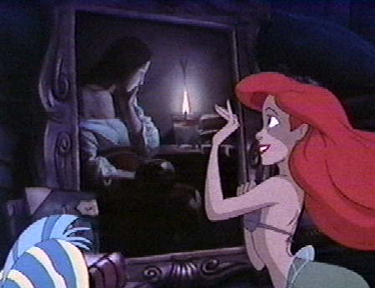
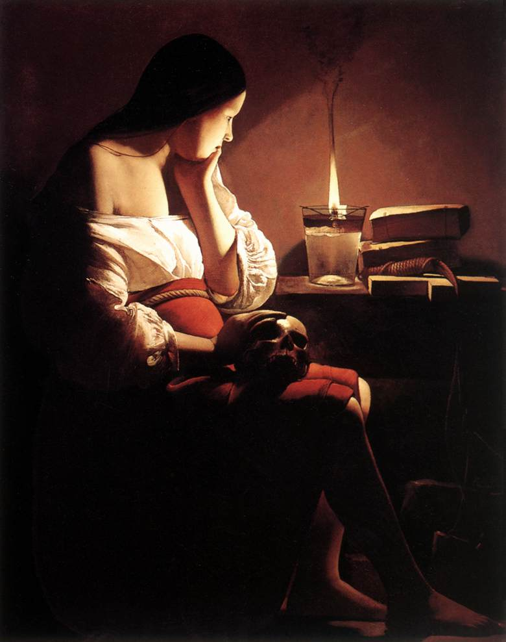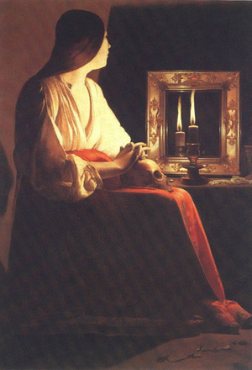
Picture from Little Mermaid Smoking Flame Penitent Magdalene

For more information about The Little Mermaid and how it relates to the Sacred Feminine, follow this link to Margaret Starbird’s essay:
http://members.tripod.com/~Ramon_K_Jusino/littlemermaid.html
http://www.danbrown.com/secrets/davinci_code/assorted.html
http://www.wga.hu/index1.html
http://www3.sympatico.ca/terri.smith/lise.eleanor/mag_2a.html

Georges de la Tour (1593-1652) Georges de la Tour was a French Baroque era painter. He mostly painted candlelit subjects. La Tour was well known in his own era. However, misidentification of the authorship of many of his paintings meant that he was not well known until quite recently. Many of his paintings have a contemplative stillness to them that is evident in his paintings of the Magdalene. His paintings hang today in such diverse locations as the Louvre, the Getty Museum, the Metropolitan Museum of Art, the National Gallery of Art, the Frick, Musée de Grenoble, and others.
http://www.wga.hu/frames-e.html?/html/l/la_tour/georges/
http://www.artcyclopedia.com/artists/la_tour_georges_de.html

Isis See Chapter 74.

Eve Heb. hawwah). “The name of the first woman, the wife of Adam, the mother of Cain, Abel, and Seth. The name occurs only five times in the Bible. In Gen., iii, 20, it is connected etymologically with the verb meaning "to live": "And Adam called the name of his wife Eve [hawwah]: because she was the mother of all the living". The Septuagint rendering in this passage is Zoe (=life, or life-giver), which is a translation; in two other passages (Gen.,iv, 1 and 25) the name is transliterated Eua. The Biblical data concerning Eve are confined almost exclusively to the second, third, and fourth chapters of Genesis (see ADAM).” (http://www.newadvent.org/cathen/05646b.htm)
God creates woman as a companion for man by taking one of Adam’s ribs and roming woman from it. She is immediately recognized as “bone of his bone and flesh of his flesh.” This implies the institution of monogamy, as there is one woman for one man. Eve is equal to Adam as she is also the object of a special and specific creative act. However, the creation passage in the Bible has also been taken as justification for the subjugation of women, as she has a secondary role and is created of man. Hence she is dependent upon man.
“The innocence of the newly created couple is clearly indicated in the following verse, but the narrator immediately proceeds to relate how they soon acquired, through actual transgression, the knowledge of good and evil, and with the sense of shame which had been previously unknown to them. In the story of the Fall, the original cause of evil is the serpent, which in later Jewish tradition is identified with Satan (Wisdom, ii, 24). He tempts Eve presumably as the weaker of the two, and she in turn tempts Adam, who yields to her seduction. Immediately their eyes are opened, but in an unexpected manner. Shame and remorse take possession of them, and they seek to hide from the face of the Lord.” (http://www.newadvent.org/cathen/05646b.htm) Because this fall is viewed as being the fault of Eve, Eve and womankind are sentenced to lives of sorrow and travail. They are also placed under the command of the husband.
The Bible does not discuss Eve much after this. “In Gen., iv, 1, we read that she bore a son whom she named Cain, because she got him (literally, "acquired" or "possessed") through God--this at least is the most plausible interpretation of this obscure passage. Later she gave birth to Abel, and the narrative does not record the birth of another child until after the slaying of Abel by his older brother, when she bore a son and called his name Seth; saying: "God hath given me [literally, "put" or "appointed"] another seed, for Abel whom Cain slew.” (http://www.newadvent.org/cathen/05646b.htm) She is mentioned a few more times, but not prominently. http://www.newadvent.org/cathen/05646b.htm

Pisces the fish goddess Pisces is an interesting constellation. The stars composing them are not bright, and the shapes are not particularly distinctive. However, the constellation does have an almost universal association with female deities.
“The ancient Babylonians recognized the Fishes as the goddesses Anunitum and Simmah; while the Syrians saw the group as a representation of their goddess Ashtatre and frequently drew it as a woman’s head upon a fish’s body. The Greeks adopted this identification, suggesting that the two Fishes represent Venus and her son Cupid.” (http://www.skyscript.co.uk/pisces_myth.html)


The constellation Pisces
http://www.scienceandart.com/photopisces.htm

Mary Magdalene She is also called Mary of Magdala. She is a saint in the Catholic Church, and her saint day is July 22nd. Mary was one of Jesus’ most celebrated disciples, and she was the first to see Jesus after the resurrection.
“The unchallenged facts about her life establish that Jesus cleansed her of seven demons (Luke 8:2 and Mark 16:9), probably implying that he cured her of a physical disorder rather than the popular notion that he freed her of sins. She was one of the women who accompanied and aided Jesus in Galilee (Luke 8:1–2), and all four canonical Gospels attest that she witnessed Jesus' crucifixion and burial; John 19:25–26 further notes that she stood by the cross, near the Virgin Mary and the unidentified Apostle whom Jesus loved. Having seen where Jesus was buried (Mark 15:47), she went with two other women on Easter morning to the tomb to anoint the corpse. Finding the tomb empty, Mary ran to the disciples. She returned with St. Peter, who, astonished, left her. Christ then appeared to Mary and, according to John 20:17, instructed her to tell the Apostles that he was ascending to God.” (Encyclopedia Britannica)
“Gnostics, pre-Christians and early Christians who believed that matter is evil and redemption is attained by an enlightened elite through faith alone, regarded her as a medium of secret revelation, so described in their Gospel of Mary, Gospel of Philip, and Pistis Sophia. According to Eastern tradition, she accompanied St. John the Evangelist to Ephesus (near modern Selçuk, Tur.), where she died and was buried. French tradition spuriously claims that she evangelized Provence (now southeastern France) and spent her last 30 years in an Alpine cavern. Medieval legend relates that she was John's wife.” (Encyclopedia Britannica) "Mary Magdalene, Saint." Encyclopædia Britannica. 2004. Encyclopædia Britannica Online. 13 Dec. 2004 <http://search.eb.com/eb/article?tocId=92748>.
For more information, follow this link: http://www.newadvent.org/cathen/09761a.htm

The Book of Isaiah Isaiah is a book of the Jewish Hebrew Bible, known to Christians as the Old Testament, containing prophecies attributed to Isaiah. It consists of prophecies delivered (Isa. 1) in the reign of Uzziah (1-5), (2) of Jotham (6), (3) Ahaz (7-14:28), (4) the first half of Hezekiah's reign (14:28-35), (5) the second half of Hezekiah's reign (36-66). Thus, counting from the fourth year before Uzziah's death (762 BC) to the last year of Hezekiah (698 BC), Isaiah's ministry extended over a period of sixty-four years. He may, however, have survived Hezekiah, and later been martyred by being sawed in half. (For more information on Isaiah's life, see Isaiah.)
The book, as a whole, has been divided into three main parts. The first thirty-five chapters, almost wholly prophetic, Israel's enemy Assyria, present the Messiah as a mighty Ruler and King. Four chapters are historical (36-39), relating to the reign of Hezekiah. Prophetical (40-66), Israel's enemy Babylon, describing the Messiah as a suffering victim, meek and lowly. In the time of Jesus the book existed in its present form. Many prophecies in the disputed portions are quoted in the New Testament as the words of Isaiah (Matthew 3:3; Luke 3:4-6; 4:16-41; John 12:38; Acts 8:28; Romans 10:16-21). Tradition has ascribed the whole book to one author. Besides this, the internal evidence, the similarity in the language and style, in the thoughts and images and rhetorical ornaments, all points to the same conclusion; and its local coloring and allusions suggest its Palestinian origin. (http://en.wikipedia.org/wiki/Book_of_Isaiah)
For more information, follow these links: http://en.wikipedia.org/wiki/Book_of_Isaiah,
http://www.christiananswers.net/dictionary/isaiahthebookof.html,
http://www.newadvent.org/cathen/08179b.htm

Meaning of “Ariel” It is Hebrew in origin, and means “lioness of God”.
http://www.babynamesworld.com/profile.php?seostats=1&name=Ariel
http://baby-names.adoption.com/search/Ariel.html

