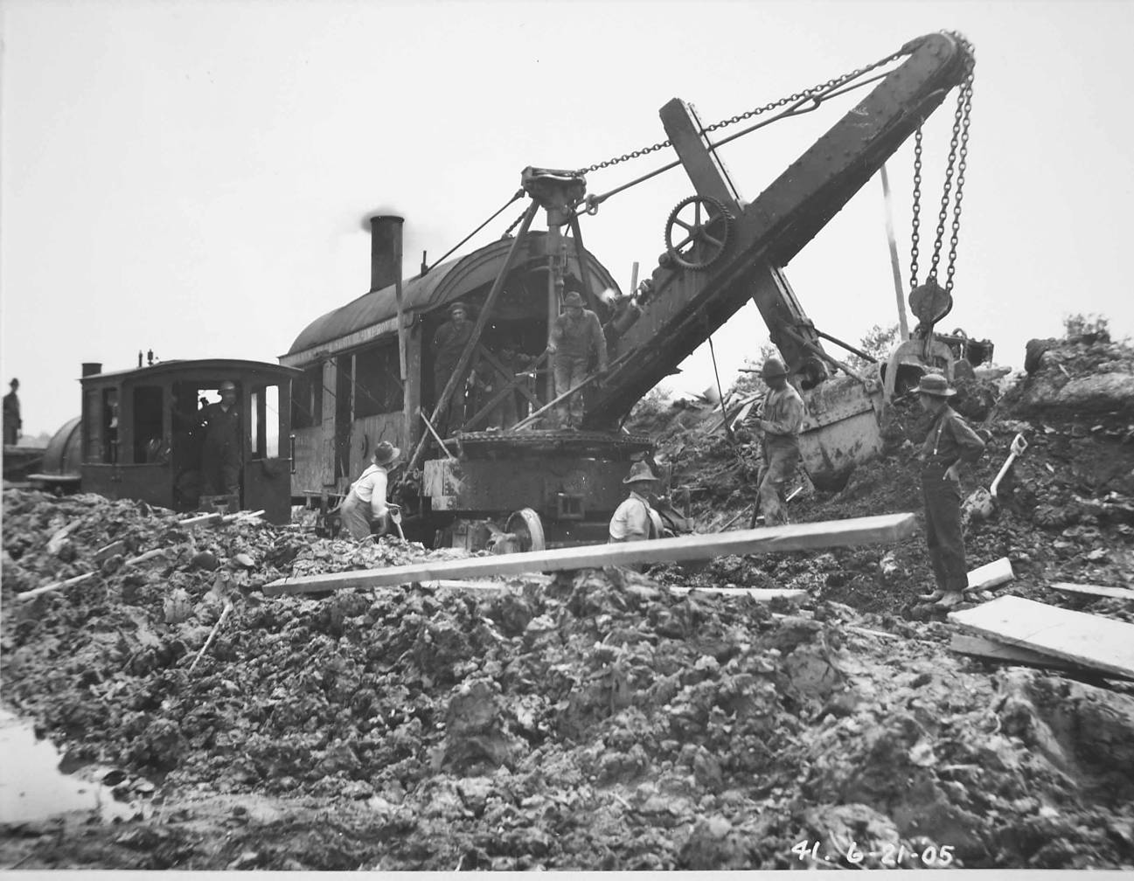

Field Trip Guide
April 22 - 24, 2005

The Champlain Canal
- Schuylerville to Whitehall -

Centenary Celebration of the "First Dig" on the Barge Canal

Canal Society of New York State

Table of Contents

Geology of Glens Falls - Whitehall Region (Grasso)... 2

A Brief History of the 18th Century
Military Construction at Fort Edward (Fuller)... 15

A Brief History of the Champlain Canal
between Northumberland and Whitehall... 23

Friday Field Trip Notes (Culligan, Jermano, Grasso and Williams)... 31

Saturday Field Trip Notes (Culligan, Jermano,Grasso and Williams)... 33

Sunday Field Trip Notes (Culligan, Jermano, Grasso and Williams)... 50

Maps... 63

Contributors

SPECIAL THANKS TO Daniel Culligan, Section Superintendent, Champlain Canal, for all his support, suggestions for stops, knowledge, and work on this field trip and guidebook.

JoAnne Fuller (Feeder Canal Alliance)

Tom Grasso (Canal Society of New York State)

John Jermano (Director Emeritus, New York State Canal Corporation)

Craig Williams (New York State Museum)

Cover illustration - Starting work on the New York State Barge Canal System at Fort Miller, June 21, 1905 (Petit Collection, New York State Museum).

GEOLOGY OF GLENS FALLS - WHITEHALL REGION

by Thomas X. Grasso

Introduction and Setting

The Glens Falls - Whitehall region can be divided into three distinct terranes or physiographic provinces: the Adirondack Uplands on the west and northwest; the Hudson - Champlain Lowlands, a natural north-south corridor containing the Champlain Canal, railroads, principal highways, and population centers; and, the Taconic Uplands on the east (Figure 1, at end of guidebook).
The Adirondack Mountains are rugged, forested hills made up of intensely deformed metamorphic rocks of Precambrian age. The Palmertown Range and Luzerne Mountains just west of Glens Falls have peaks from 1,100 to 1,500 feet above sea level, whereas the West Mountain Range, north of Fort Ann and west of Whitehall display pinnacles ranging from nearly 500 feet (Battle Hill, just north of Fort Ann) to 1,900 feet (Vanderberg Mountain) above sea level. These lofty heights contrast sharply with the nearly level plain surrounding Glens Falls at an elevation of 300 to 400 feet above sea level or the "flats" of the Wood Creek - Mettawee River Valley at Whitehall of 120 feet.
The Hudson Champlain Lowland is open, sparsely wooded, farmland of low relief having elevations of 400 feet or less. Immediately east and southeast of the Adirondacks, the province is underlain by sedimentary rocks, principally limestones and dolostones, of Late Cambrian and Early and Middle Ordovician age (in ascending order the Beekmantown, Black River, and Trenton Groups and shown on Figures 2 and 3). However, a wide belt of shale, the Middle Ordovician Snake Hill Formation, underlies the lowland east of the carbonate (limestone and dolostone) belt from the Fort Ann parallel south. Hudson Falls, Fort Edward, Fort Miller, Northumberland, and Schuylerville are all underlain by the Snake Hill. The bedrock is mantled by a mosaic of glacial deposits, chiefly sands and clays deposited in proglacial high level lakes.
The third terrane, the Taconic Uplands, is a moderately rugged region of north-south trending hills ranging from 400 to 1,100 feet elevation. The Taconic Mountains form the eastern spine of New York State from Vermont, northeast of Whitehall, south to Connecticut. The Taconics are composed of Late Precambrian through Middle Ordovician, intensely folded (anticlines and synclines) and faulted, sedimentary and metamorphic rocks.
The entire Glens Falls - Whitehall region is structurally complex. Numerous high angle, nearly vertical, normal faults chop the eastern Adirondack and Champlain Lowland into large rectangular blocks, much like a chess board. That is because there are two primary sets of faults, one that trends north-south or northeast-southwest and another set trending in nearly an east-west direction. A normal fault is one produced by tensional forces and results is one side of the fault moving down relative to the other side of the fault. The downthrown block is the one toward which the fault plane dips. If the fault plane dips (slopes into the earth) west, the west side of the fault drops down relative to the east side of the fault. If the fault dips south, the south side of the fault drops down and so forth. In this way, younger strata on the downside of the fault can be juxtaposed older rocks on the upside of the fault (Figures 4, 5).
In the Champlain Lowland, it is not uncommon to observe the Potsdam Sandstone lying up against the Precambrian with a fault contact instead of its normal superposition upon the Precambrian. Even more profound examples exist in the region as described below and shown on Figure 4.
Lake George is located in a down-faulted valley (graben), normal faults bounding it on its east and west sides. The same is true of South Bay at the southern tip of Lake Champlain. West Mountain between the Wood Creek Valley (Champlain Canal) and South Bay has been uplifted along the fault that borders the southeast side of the Bay. Going in a southerly direction, West Mountain would include first Vanderberg Mountain, then Orebed Hill, the Pinnacle, and, lastly, Battle Hill at its southern terminus just north of Fort Ann. The west boundary of the south portion of West Mountain is made up of another normal fault trending almost due north-south. This is the Welch Hollow Fault that can be mapped from a point just east of Smith's Basin north through Fort Ann and continuing almost due north through Welch Hollow. Welch Hollow is the valley due north of Fort Ann, between Putnam Mountain (west side) and West Mountain (east side, curiously enough), that hold County Road 16 and the south flowing tributary to Halfway Creek (Figure 4). The face of Kanes Falls on Halfway Creek, about one mile northwest of Fort Ann, is a fault line scarp on another normal fault. The present Champlain Canal is located parallel to and just west of the Welch Hollow Fault from Smith's Basin to Fort Ann. In this stretch, the Late Cambrian Potsdam Sandstone and Ticonderoga Formation are on the upthrown side of the fault on the east bank of the canal while the Middle Ordovician Snake Hill Formation is on the downthrown west side. North of Fort Ann, the canal crosses the Welch Hollow fault when the canal turns northeast at the base of Battle Hill. From Fort Ann north to the easterly bend, Precambrian rocks are on the east side of the canal while Middle Ordovician Isle la Motte and Glens Falls Limestones are on the west.
Where the canal turns northeast at the base of Battle Hill, it follows the trace of another fault line, the Battle Hill Fault that crosses the Welch Hollow fault. Nearly two miles northeast, at Dewey's Bridge, the canal turns north again to Comstock, this time along the Dewey's Bridge Fault. Since the canal is in the canalized Wood Creek from Smith's Basin to Comstock, the flow of the creek was originally controlled by these and other faults (Figures 4, 5).
Throughout much of the Champlain Lowland Province, the strata are not only faulted but also contorted and folded into anticlines and synclines. This is especially true east of Hudson Falls and northeast, from here along the canal, as well.
The Taconic Uplands are very tightly folded but also are thrust faulted. Thrust faults are large offset faults that result from compressional forces wherein the upthrown side of the fault is the one towards which the fault dips (Figure 5). Generally, thrust faults have a low angle of dip. Therefore, the upside of the fault overrides the downthrown, thereby resembling shingles on a roof at the conclusion of faulting. In the Taconic Mountains the thrust faults dip east therefore the older rock is on the east side and since the fault planes dips so gently older rocks come to rest upon younger. Commonly, the top of a hill or mountain contains older Cambrian or sometimes Precambrian rock while the base is made up of Middle Ordovician rock units, a thrust fault contact separating the two. The Smith's Basin Fault is a relatively low displacement thrust west of the Taconic.

Drainage

The major streams in the study area are the Hudson River, Bond Creek, Dead Creek, and Wood Creek (Figure 1, at end of guidebook). The Mettawee River joins Wood Creek just south of Whitehall. The Hudson River enters the area through the watergap north of Palmertown Mountain, west of Glens Falls. It then meanders east to Glens Falls where is drops 50 feet over the Trenton and Black River limestones, just west of the bridge that carries US Route 9 over the river. East from here, to the village of Hudson Falls, the river is mostly on a rock floor to Bakers Falls where it drops 65 feet, cascading over the Snake Hill Shale. Here, also, the river turns south toward Fort Edward and its long journey to the Atlantic Ocean (Figure 6).
Bond Creek flows south rising northeast of Glens Falls and Hudson Falls and joins the Hudson at Fort Edward across from Rogers Island. Earlier, James Geddes mapped this creek as Fort Edward Creek and in colonial times it was called Little Wood Creek. Old Fort Edward was built on the north bank of Bond Creek at its junction with the Hudson River (Figures 11, 12).
Dead Creek, flowing southwest, is another tributary to the Hudson via the Moses Kill. It flows into the Moses Kill about three miles north of Fort Miller. More significant is the fact that it rises in a swamp, about three miles due east of Hudson Falls at an elevation of approximately 155 feet above sea level. Flowing north out this same swamp and only 1,200 feet away is Wood Creek. With shades of the "Carrying Place" at Rome or Geddes' Singular Brook east of Fairport, Wood Creek flows north to Smith's Basin where it receives the waters of Big Creek from the east. At Fort Ann, Halfway Creek joins Wood Creek from the west and, just south of Whitehall, between Tub and Skene Mountains, the Mettawee River contributes its run off from the east.

Bedrock Geology

The geologic history of the Glens Falls - Whitehall area began 1.4 billion years ago when rocks of uncertain origin were formed in the Adirondack Mountains. The younger Lake George Group was deposited as sediments in a shallow ocean over 1.1 billion years ago.
These Precambrian rocks were reconstituted by heat and pressure, intensely folded, remelted and intruded by molten rock during the long lasting Grenville Orogeny (mountain building episode) 1.1 billion years ago. The Adirondack Mountains had formed. Today, these metamorphic and igneous rocks, particularly the Lake George Group (Hague Gneiss and Brant Lake Marble with igneous dikes) can be seen on road cuts along US Route 4 north-northeast of Fort Ann and at the falls and Lock 12 in Whitehall.
During late Precambrian time, a single large tectonic plate (Laurasia) began to break apart by rifting. Eventually, the continent broke apart giving rise to an ever-widening sea in between called Iapetus, the ancestral Atlantic Ocean. From Late Precambrian time through Early and Middle Cambrian time, this ocean lay east of the present Hudson - Champlain meridian. Therefore, northeastern New York was probably a land surface undergoing erosion.

Late Cambrian Period - Beekmantown Group

During Late Cambrian time (520 to 500 million years ago), the Glens Falls - Whitehall region was flooded from southeast to northwest by a shallow sea. A broad continental shelf was now forming over the study area and the initial deposit of this transgressive sea was the Potsdam Sandstone. Today, the Potsdam Sandstone forms the base of the Beekmantown Group. It rests, where unfaulted, with a dramatic unconformity (break in the rock record) on the Precambrian metamorphic Lake George Group. The Potsdam Sandstone was deposited in a near shore, inner shelf beach and/or intertidal to shallow subtidal environment. It often displays magnificent ripple-marked surfaces and cross bedding (thin laminae within one stratum inclined at an angle to the stratification), indices of high current activity. The coarse-grained texture of the rock combined with its rare fossils further advance the inference that the Potsdam was a near-shore deposit.
The Potsdam ranges from 85 to 200 feet thick, is a good building stone, and is used in curbing and buildings such as the library in the village of Fort Ann. It is exposed at the base of Skene Mountain in the village of Whitehall, just east of Lock 12, along US Route 4 northeast of Fort Ann, and in the abandoned quarries on the east side of the Champlain Canal, north of Smith's Basin and Fort Ann along the Welch Hollow Fault.
The overlying Ticonderoga and Lower Whitehall Formations were deposited in the intertidal to very shallow subtidal zone. The Ticonderoga is 150 to 240 feet of quartz dolostones interbedded with dolomitic to pure quartz sandstone. The Lower Whitehall is 160 feet of purer lime rock such as dolostone and limestone. Local stromatolitic (algal) mounds named Cryptozoon and rare trilobites characterize the Ticonderoga - Lower Whitehall sequence but more so the Lower Whitehall. These units are always found above the Potsdam Sandstone (such as at Skene Mountain in Whitehall) except where erosion has removed them and only the Potsdam remains or where faulting has interrupted the normal sequence.
The Ticonderoga Formation has locally been used for building stone and for old Champlain Canal lock and aqueduct construction.

Early Ordovician Beekmantown Group

The Early Ordovician (500 to 465 million years ago) portion of the Beekmantown group is made up of 800 feet of limestone and dolostone of the Upper Whitehall, Great Meadows, Fort Ann, and Fort Cassin Formations, from older to younger. They represent deposition in the lower intertidal to shallow subtidal zone and many units yield a high diversity of invertebrates such as trilobites, brachiopods, and mollusks like gastropods (snails) and cephalopods (pearly Nautilus type). Fossils are abundant in the Great Meadows Formation (Kingsbury Limestone and Fort Edward Dolostone Members), Fort Ann Formation, and Fort Cassin Formation (Scotia Limestone Member). Chert (flint) stringers and nodules in the Lower Whitehall and Great Meadows Formations (Finch Dolostone and Fort Edward Dolostone Members) are the "Fort Ann Flints" of early reports and were used by Native Americans for making chipped stone tools.
The various Beekmantown formations were quarried to construct fortifications and artillery sites in colonial times and for old Champlain Canal structures. The Fort Ann and Great Meadows Formations were used extensively in canal construction. Much of the Beekmantown Group stone was quarried southwest of Kingsbury Village, along a thirty-foot high ridge near the east edge of a tributary to Fort Edward (now Bond) Creek. The outcrop appears on James Geddes' 1825 map of the Champlain Canal (Figure 6). Exposures of the Early Ordovician Beekmantown Group include the upper portion of Skene Mountain, Tub Mountain south of Whitehall, Kanes Falls on Halfway Creek, the village of Kingsbury district, the hills east of Smith's Basin, and ridges northeast of Glens Falls.

Middle Ordovician - Black River and Trenton Group

The tectonic plate that had split in Late Precambrian time reached its maximum divergence at the end of the Early Ordovician. The Paleozoic Atlantic (Iapetus) now began to narrow as ancestral Europe began to move back toward ancestral North America. This event was heralded by an upwarp of the eastern margin of North America at the onset of the Middle Ordovician as compressive forces now replaced tensional ones that had prevailed for so long. The seas receded and exposed the Glens Falls - Whitehall region to extensive erosion, forming a major erosion surface or unconformity.
Later on, in the Middle Ordovician, shallow seas returned to the region and extensively flooded New York State. The depositional sequence begins with the Black River Group, represented in the study area by the Isle la Motte Limestone. This unit is up to 65 feet thick and consists of massive bedded, dark gray to black, light gray weathering, fine-grained limestone. Fossils are relatively scarce in the Isle la Motte but some cephalopods, gastropods, brachiopods, and corals are found; including the relatively large snail (3 to 4 inches in diameter), Maclurites logani. The fine-grained texture of the rock supports a quiet water origin for this unit. In addition, the low faunal diversity suggests relatively high environmental stress. Therefore, we infer the Isle la Motte was deposited in a nearshore lagoon.
The Isle la Motte, known as the Glens Falls "Marble" in older reports, was formerly quarried for facing and building stone. On the south side of the Hudson River and downstream from Glens Falls, large joint-bounded blocks were easily obtained from the river bed and lower portions of the bank. Nearby, there were marble mills, probably water powered, that sawed the "marble" into slabs and other suitable forms for fireplaces, tables, window and door caps and sills. The Isle la Motte Limestone was mostly shipped to the New York City market although some of it was used on the Erie Canal and the Champlain Canal. Several blocks can be seen in the combined locks at the east edge of Fort Ann (Locks 16, 17) and the five-combined locks (Locks 6 to 10) on the Glens Falls Feeder Canal down from Burgoyne Avenue (Saturday Stops 3 and 7).
The Isle la Motte is exposed in the face of the falls on the Hudson River at Glens Falls; in the banks of the river and feeder canal downstream to the west edge of Hudson Falls; in the abandoned quarries north of the Hudson River near the east edge of Glens Falls; and, in the abandoned quarry, east of the road to Adamsville, southeast of Smith's Basin on the upthrown side of the Smith's Basin Thrust Fault. Here, it was burned for agricultural lime.
The overlying Glens Falls Limestone of the Trenton Group was deposited in the more agitated and turbid waters of the shallow subtidal shelf. It is 70 to 115 feet of thin-bedded, medium to coarse-grained, gray to black, very fossiliferous limestone. The Glens Falls Limestone is exposed at the top of the falls on the Hudson River in Glens Falls, just upstream from the bridge carrying US Route 9 over the river. At this falls, "Cooper's Cave" can be viewed downstream from the bridge in the Isle la Motte Limestone. It is this cave that figured so prominently in James Fenimore Cooper's classic tale of the French and Indian War, The Last of the Mohicans. The Glens Falls Limestone is also exposed in the upper portion of the south bank of the Hudson River downstream from Glens Falls, in the active quarry on the south bank of the river and north of Ferry Boulevard in South Glens Falls, in the abandoned Jointa Quarry in Glens Falls on the north side of the river south of Oakland Avenue, and, along Bond Creek (Fort Edward or Little Wood Creek) upstream and downstream from Washington County Road 41 (Smith's Basin Road or Mud Street).

Snake Hill Formation

Late in Middle Ordovician time, an island arc (Bronson Hill) that had previously formed in what is now central New England collided with eastern North America. Dramatic and catastrophic events took place as the earth's crust heaved, buckled, folded, and faulted to relieve the awesome compressive forces that now struck eastern New York and western New England. The Appalachian Mountains were beginning to form as the Green Mountains of Vermont, Berkshire Highlands of Massachusetts, and Taconic Mountains of eastern New York came into existence. The Taconic Orogeny was now underway. Like a "teeter-totter" effect, as the mountains to the east rose, a deep basin developed to the west along the Hudson Valley meridian. Into this deep basin, detritus (erosional debris) from the rising highlands to the east was deposited, forming the 1,500-foot thick Snake Hill Formation. It is a fine-grained, dark gray to black shale and mudstone with few siltstone beds. It yields a low diversity fauna, mostly of floating and swimming species (pelagic). The dark-color, fine-grained texture of the rock and meager pelagic fauna all suggest deposition in very deep, low oxygenated basin waters. The anoxic conditions present in the deep water prevented the establishment of a bottom-dwelling fauna. Yet, the oxygenated waters above could support pelagic organisms. After death, their remains settled to the bottom where the lack of oxygen and the absence of a bottom-dwelling, sediment-shifting fauna insured their preservation.
Harder calcareous beds and mudstones within the unit account for the many falls in the region as these beds are more resistant to erosion than the underlying and overlying shalier portion of the unit. Thus, Bakers Falls at the village of Hudson Falls was etched into relief by the Hudson River flowing over these harder limey mudstones. The same is true of the falls at Fort Miller around which the 1819-1822 Champlain Canal was constructed and Saratoga Falls just south of Northumberland. Barge Canal construction has virtually eliminated the significance of the later two falls by blasting or building dams and locks such as the dam and Lock 6 at Fort Miller, the dam at the north end of Thompson Island, and the dam (Northumberland) and Lock 5 (just north of Schuylerville).
The Snake Hill Formation and the underlying older sedimentary rocks were contorted, folded, and faulted by Late Ordovician Taconic mountain-building forces. These same strata were most likely remobilized by orogenic forces that came later in the Devonian Period and Late Paleozoic Era.
By the start of the Late Ordovician Period the Snake Hill basin had completely filled and a large delta, the Queenston Delta, had formed from the sediments derived from the Alpine-like mountains to the east. This swampy delta began at the base of the newly uplifted mountains but, with time, eventually shifted west such that by the end of the Late Ordovician Period the delta had completely covered the state. Subsequent erosion removed the deltaic sediments in the east leaving the Snake Hill Shale as the youngest bedrock formation in the study area. Late Ordovician mountain building forces and perhaps Devonian orogenic events as well imparted the slatey cleavage that is so well displayed in the Snake Hill Formation of the Hudson Valley region but equally in the rock formations that comprise the Taconic Mountains to the east. During the construction of the 1820s Champlain Canal, the peculiar fabric or structure of the Snake Hill Formation caused the engineers many problems. The steeply-inclined bedding planes cut at nearly right angles by slatey cleavage and a third plane of weakness caused by joint fractures render this unit unstable in open cuts and excavations. The shale can also swell when exposed to atmospheric conditions and, therefore, deteriorate. The harder limey mudstone layer in the vicinity of the falls previously described only compounded the problems that beset the construction crews. Slope instability and difficult rock conditions apparently caught the Ditch-era contractors unawares.
The Snake Hill Formation underlies all of the region along the Hudson River meridian from Fort Ann south. It is well exposed at Bakers Falls on the Hudson River at the village of Hudson Falls and at many other localities and road cuts on both sides of the Hudson River Valley south of Smith's Basin. The Snake Hill Formation occupies a wide belt ten to fifteen miles wide from just south of Glens Falls all the way to the base of the high Taconics in the east.
Since no rock formations younger than the Snake Hill are present in the study region, geologists conclude that the area has remained above sea level since the end of the Ordovician. Later mountain building events such as the Acadian Orogeny in the Devonian Period and the Appalachian Orogeny near the end of the Paleozoic Era must have affected the Glens Falls - Whitehall region but little direct evidence can be found of their impact save for the similar slatey cleavage overprint that affects both the rocks in the Taconic Mountains and the Snake Hill Formation.
In the Late Triassic and Early Jurassic Period the supercontinent of Pangaea, that had formed earlier in the Paleozoic Era, began to break apart by rifting. The modern Atlantic came to occupy the widening gap between the drifting continents much like Iapetus did from Late Precambrian through Early Ordovician time. The tensional forces that prevailed throughout eastern North America during the initial phases of rifting, in the Early Mesozoic Era, resulted in extensive normal (block) faulting, creating linear highlands and basins. The Connecticut Valley was formed at this time by block faulting. Many of the north-south trending faults in the Glens Falls - Whitehall region were probably activated at this time such as the Lake George West Faults and west-east to southwest-northeast trending faults as well such as the Sawmill Pond Fault and the Battle Hill Fault.

Pleistocene Ice Age

Just before the Ice Age (2 million years ago) the surface drainage was dramatically different than today. A preglacial divide in drainage was probably located near Fort Ann at Battle Hill. A north-flowing, preglacial Wood Creek drained into a major stream flowing north in the Lake Champlain Valley while a south flowing Wood Creek on the other side of the watershed was a tributary to the south-flowing Hudson River, perhaps through the channel that now holds the Champlain Canal near Fort Edward. Welch Hollow and Halfway Creek could have flowed south and west toward the Hudson River, not north to Lake Champlain as they do today. Certainly, the Hudson River was in a different location from its present course through Glens Falls and Hudson Falls. The gorge, waterfalls, and rapids indicate a postglacial origin for the Hudson here. The Hudson River could have flowed southeast through Warrensburg and Lake George Village past Glens Falls to the west and joined its present position near Fort Edward. The present Lake George valley could have originally contained a south-flowing tributary to the preglacial Hudson River, joining it at Lake George (Figure 7).
With the onset of glaciation the Fort Ann divide was breached by glacial erosion as the ice flowed south toward its maximum advance at Long Island. As the ice melted back to Schuylerville, about 14,000 years ago, the Hudson Lobe of the ice sheet defended ice-marginal Lake Albany at an elevation of over 400 feet south of Schuylerville. Fine muds deposited on the floor of Lake Albany form the thick clay deposits on the sides and floors of the Hudson Valley and were the source material for the Valley's famous brick industry.
The ice margin of the Hudson Lobe then melted north to near Smith's Basin about 13,500 years ago. Lake Albany lowered to 320 feet elevation, forming Lake Quaker Springs (Figure 8, at end of guidebook). Interchange 18, the Glens Falls Interchange, on the Northway (Interstate 87) is only 60 feet above the level of Lake Quaker Springs and only two miles from its beach. The Hudson River, when it encountered the lake, deposited its load of sand and gravel, forming the Glens Falls Delta. The delta accounts for the sandy soil in and around Glens Falls.
Further northward withdrawal of the ice margin to Whitehall lowered Lake Quaker Springs 80 feet thereby ushering in Lake Coveville at 260 feet elevation (Figure 9). The postglacial Hudson River extended its course eastward and emptied into the lake at Hudson Falls where it deposited the sandy Hudson Falls Delta. Hudson Falls was once known as Sandy Hill. As this time Glens Falls was initiated as a small cascade of about 20 feet and began its retreat upstream leaving behind a bedrock gorge. The western shore of the lake closely paralleled Country Road 41 from Hudson Falls village to near Smith's Basin. The five-combined locks of the Glens Falls Feeder (Locks 6 through 10) carry the canal across the sharp east facing slope of the hanging delta. Meanwhile, the valley floor northeast from Fort Edward accumulated lake clays not only from Lake Coveville but Lake Quaker Springs as well. These clays were used in the pottery industry of Fort Edward.
The Hudson Lobe retreated northward once again about 13,000 years ago and Lake Fort Ann I was born at an elevation of 210 feet (Figure 10). Like its ancestors, Lake Fort Ann I drained south to the Atlantic through the lower Hudson Valley. It is perhaps as useful to think of Lake Fort Ann as a wide river more so than a lake as it was quite shallow with a significant south flowing current. In the study region Lake Fort Ann I had three channels - the primary Fort Edward Channel, now occupied by the Champlain Canal; the Durkeetown Channel of Dead and Wood Creeks; and, the Winchell Channel from Smith's Basin to Dewey's Bridge (Figure 10). The sand terrace at approximately 210 feet northeast of Fort Edward marks the lake's shoreline. Also, at this time, Glens Falls was made higher as the river dropped in elevation and Bakers Falls came into existence.
Combined Locks 2 and 3 as well as Locks 4 and 5 of the Feeder ascend westward the lacustrine terrace of not only Lake Fort Ann I but its descendant lower level Lakes Fort Ann II and III. The lake bottom clays from Lake Albany to Lake Fort Ann III that line both sides of the Hudson Valley can become quite unstable when they become wet due to increased rainfall, melting snow, or hydrostatic pressure from buried springs. Many landslides have taken place over the years throughout the region, especially during the spring. During Barge Canal construction, one such event caused Barge Lock 7 to be relocated a few hundred feet further south to its present site on the south edge of Fort Edward. One landslide at Troy in the summer of 1836 crushed three houses and two barns, killing five people and sixteen horses.
When Lake Fort Ann III came into existence at 140 feet, at Fort Edward, the Winchell and Durkeetown Channels were abandoned, leaving behind a swamp on previously deposited lake clays in the Durkeetown Channel at an elevation of 155 feet. This swamp now became the current divide in drainage between the north-flowing Wood Creek and south-flowing Dead Creek.
Finally, when the Hudson Lobe melted north past Plattsburgh, the present northward drainage was established to the Saint Lawrence River. At Whitehall the now combined waters of the Mettawee River and Wood Creek were relocated to a new postglacial location and formed the waterfalls there over the Precambrian Hague Gneiss at the base of Skene Mountain along the contact with the overlying Potsdam Sandstone. Lock 12 on the Champlain Barge Canal and combined Lock 21, 22, and 23 on the old canal were constructed to overcome the elevation difference of the falls. Earlier, in the 1790s, the Northern Inland Lock Navigation Company attempted lock construction at this site as well.

Acknowledgements

Special recognition is given to Richard D. Hammell (Monroe Community College) for drafting the maps contained therein. His formidable and superior talents at computer drafting are quite evident.

References

Connally, G. Gordon
1973 Surficial Geology of the Glens Fall Region, New York. New York State Museum Map and Chart Series No. 23 (map only).

DeSimone, D. E. and La Fleur, R. G.
1985 "Glacial Geology and History of the Northern Hudson Basin, New York and Vermont" in Lindemann, R. H., editor, New York State Geological Association Guidebook, 57th Annual Meeting, Skidmore College, Saratoga Springs, p.82-116.

Fisher, D. W.
1984 Bedrock Geology of the Glens Falls - Whitehall Region, New York. New York State Museum Map and Chart Series 35, 58 pages, 3 plates including geologic map.

Mather, W. W.
1843 Geology of New York, Part 1, Comprizing a Survey of the First Geological District. Carroll and Cook, Albany, N.Y., 653 pages, 46 plates.

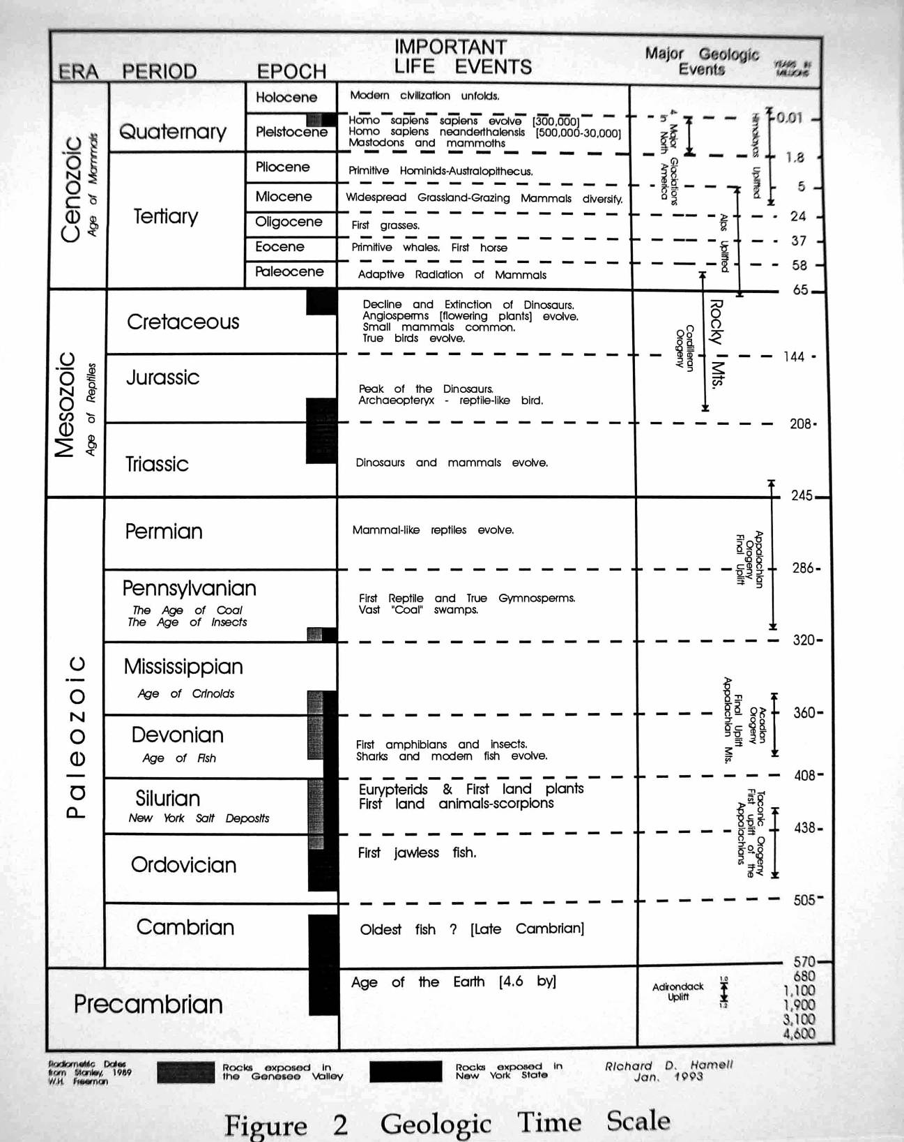
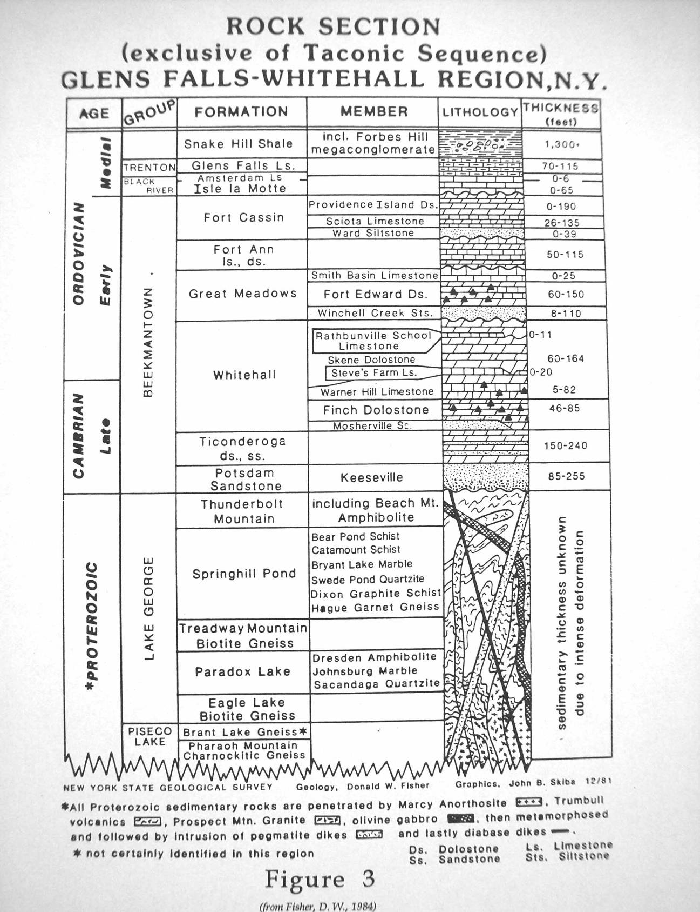

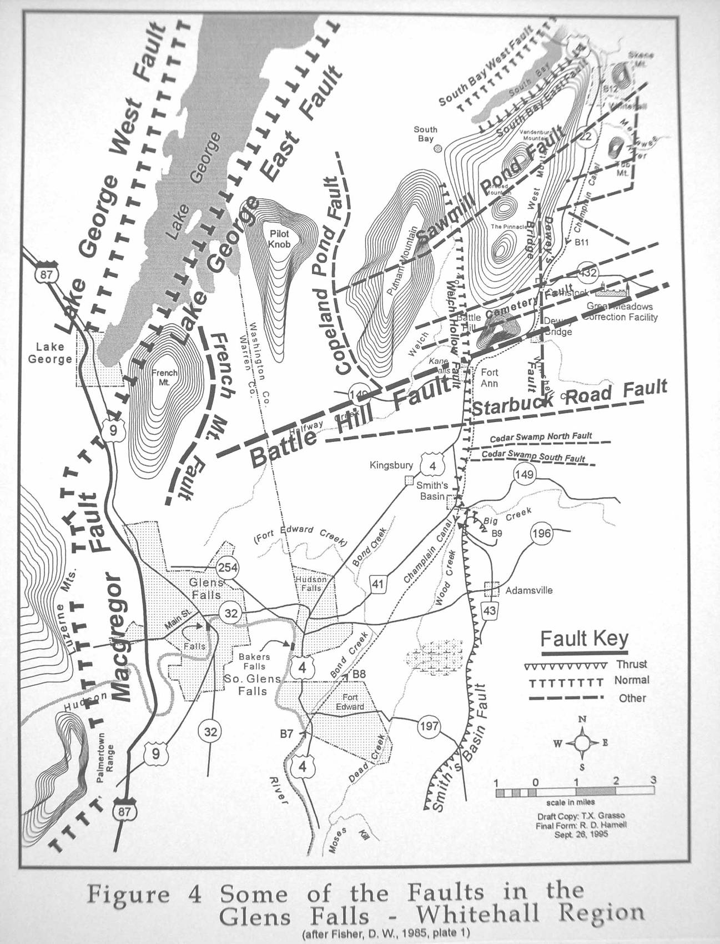
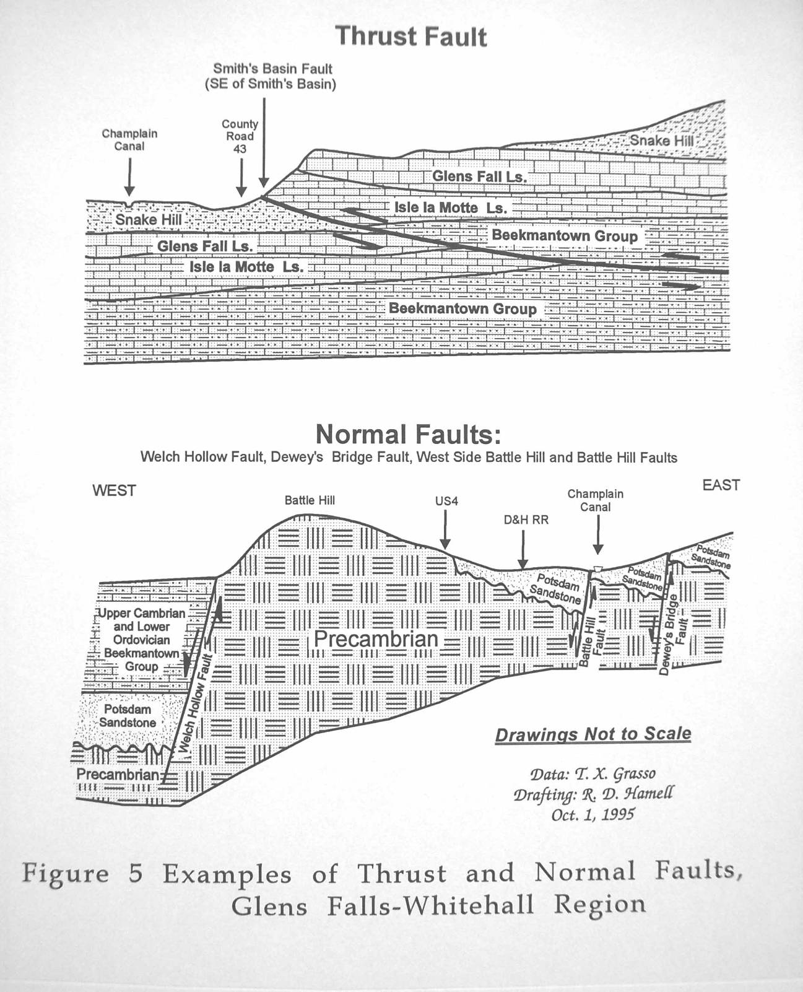

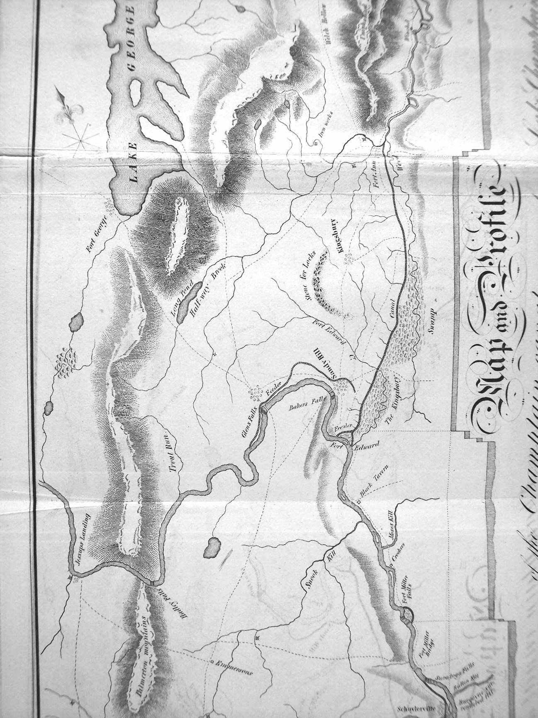

Figure 6. From Geddes' 1825 map of the Champlain Canal.
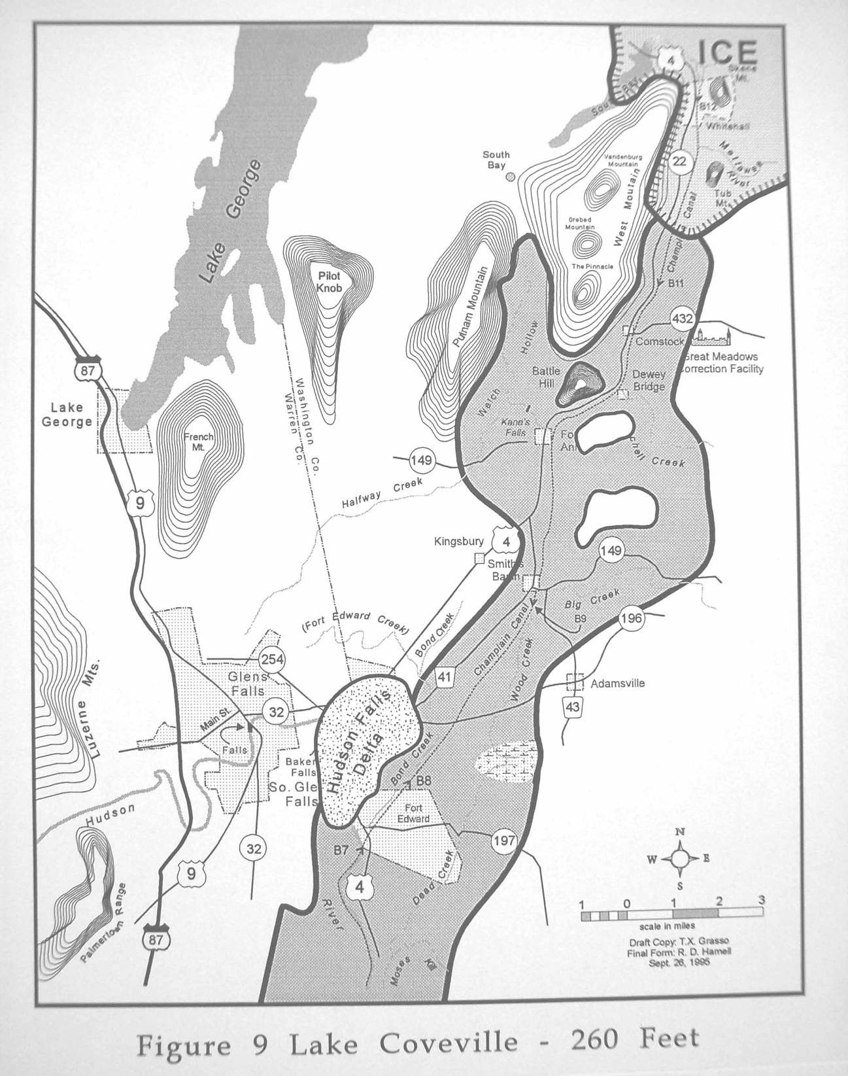
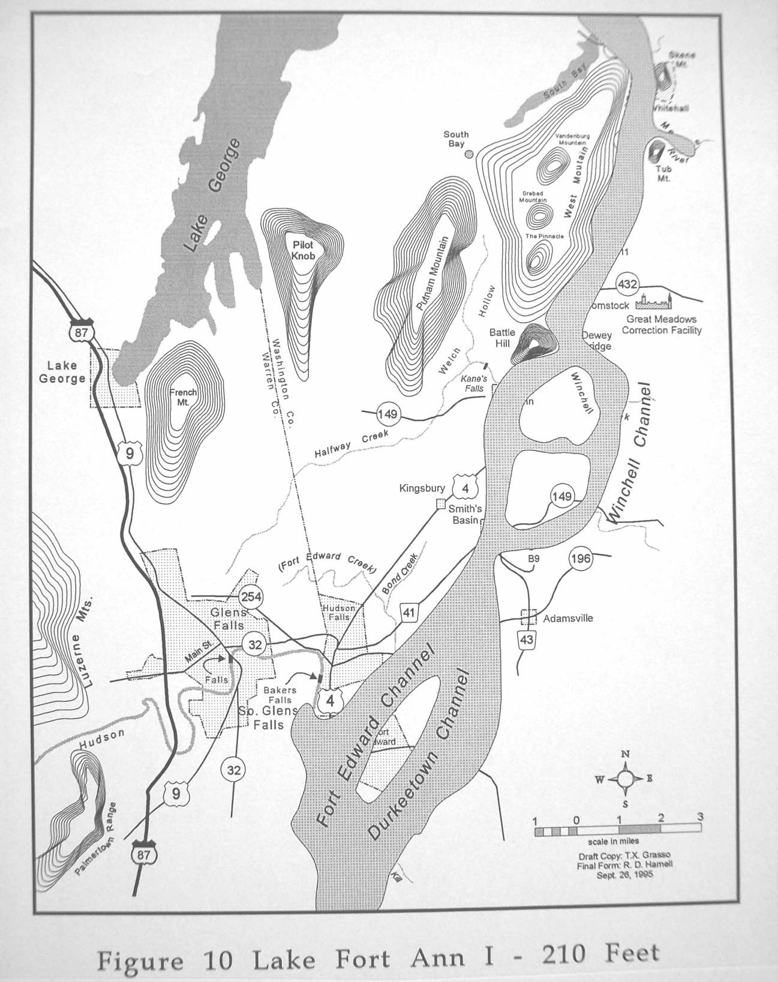

A BRIEF HISTORY OF THE 18TH CENTURY
MILITARY CONSTRUCTION AT FORT EDWARD

by JoAnne Fuller

The Great Carrying Place, as Fort Edward was known during the 17th century, was the major portage between the Hudson River and the headwaters of Lake Champlain. The geographic location of the Carrying Place became a strategic military and economically advantageous junction between the Hudson and Champlain Valleys. The wars between the Canadian French and the English-occupied colonies raged for nearly a century throughout northeast New York State. Although Fort Edward played a significant role in all of these 18th-century military conflicts, an extensive fortification was not constructed until the outbreak of the Seven Years War, more commonly known as the French and Indian War.
The first recorded English military expedition against Canada to have passed through the Great Carrying Place was led by Major General Fitz-John Winthrop in 1690. Thwarted by sickness, Winthrop and his 150 troops never made their way into Canada. The following year another English campaign was launched against Canada, this time led by Peter Schuyler, mayor of Albany. Schuyler, commanding fewer than 300 men, camped at the Great Carrying Place on his way to LaPrarie. As early as 1696, the Reverend Godfredius Dellius, then minister of the Dutch Reformed Church at Albany, was able to obtain an individual patent for 537,600 acres of land from Benjamin Fletcher, colonial governor of New York. The Dellius patent included the area known as the Great Carrying Place, now the town of Fort Edward.
Dellius had plans to initiate a profitable business venture on his newly acquired land. A letter written in 1699 by the Earl of Bellomont reads in part -

I understand there area as good pines for masts of ships on the land granted to Mr. Dellius by Colonel Fletcher as any there are in New Hampshire, and a great number of them, and they may be floated on the river all the way for Yorke [New York] with little or no charge. Neither is there any reservation of quitrent to the Crown, except one racoon's skin per annum, nor the liberty of cutting a tree or building a fort. Mr. Dellius has lately had ninety masts for ships floated down from that land to a place within a few miles of Yorke [New York] on Hudson's River, and that by way of essay and proposes to himself great profit by sending masts down river and selling them in this town.

The first fortification constructed at the Great Carrying Place was built by Peter Schuyler in 1709 during the English and French conflict known as "Queen Anne's War". Schuyler named Fort Nicholson for his English commander, Colonel Francis Nicholson of Connecticut. The fort was garrisoned by 450 men, including "seven companies of regulars in scarlet uniform from old England". As many as 700 British soldiers may have garrisoned Fort Nicholson until 1711 when the fort was abandoned by the army. Fort Nicholson was described in 1749 by botanist and traveler, Peter Kalm, as simply a "wooden fortification."
John Henry Lydius arrived at Fort Nicholson in 1731 to build a trading post. Claiming to own the original land patent granted to Dellius in 1696, the Dutch fur trader from Albany constructed his trading post on the site of the old fort. He and several Dutch families enjoyed a lucrative trade with the French and Indians until 1745 when the French once again began mounting expeditions against the English. It was during one of these raids that Fort Lydius, as the French often called the fortified trading post, reportedly was burned to the ground. It is unknown whether the Lydius post was truly destroyed during the 1745 raid or reconstructed before the outbreak of the French and Indian War.
Contemporary documents reveal the Lydius house was incorporated into the construction of Fort Edward in 1755. In a letter to Governor William Shirley from General William Johnson, dated May 1, 1755, Johnson wrote -

...forts indispensably necessary to be built at the most important and dangerous passes, which may not only favor a retreat in case of any disaster but will be proper serve as magazines for lodging provisions in, and also as hospitals for sick and wounded. The first I propose to be built at, or near Mr. Lydius' place from whence we must have everything carried by land to a place called South Bay...

Instructions to begin building a fort at the Lydius Place were issued to Major General Phineas Lyman from General William Johnson on July 17, 1755. In part, they stated -

You are to proceed with your command to the house of Col. Lydius near the Carrying Place where you are to erect log magazines covered with bark sufficient to contain and secure from the weather, the ammunition, provision & c belonging to the Army under my command.

General Lyman and a number of Provincial soldiers arrived at the Great Carrying Place in early August of 1755 and immediately began the construction of a storehouse and magazine. Johnson arrived within a few days accompanied by King Hendrick, Joseph Brant, and fifty Mohawk warriors. Johnson immediately set up camp on the "Great Island" across the Hudson River from the area where Lyman and his troops were building a fort. Johnson was soon joined by 200 more Indians. The total number of troops reported at this time were 2,850 men.
Fort Edward was initially built as the supply depot to Fort William Henry, the latter being constructed as the northern most defensive British fort. Both forts were designed and constructed about the same time in 1755 by the same engineer, Captain William Eyre, chief engineer for the British Army.
Johnson wrote to Thomas Pownall on August 24, 1755 from the Carrying Place -

Captain Eyre has laid out a piece of fortification here round Lydius's log house, which if finished, would be serviceable in case of retreat, but as it is thought to large by most of the officers and cannot be finished before we go...

Eyre described the fort a short time later in a letter dated September 10, 1755 -

I have built a fort at the Carrying Place which will contain 300 men, it is the form of a square with three bastions and takes in Col. Lydius's house; this work is palisaded quite round, which is its chief security from a surprise...

A blacksmith's shop, magazine for powder and a hospital appear to be the first new buildings constructed in the fort. A report given by Field Officer Timothy Ruggles on August 16, 1755 stated -

...according to public orders, have myself with such officers as I though proper, pitched upon places to erect a magazine for powder and to build a hospital on, and upon examining the ground are of opinion that the best place for a magazine is at the southeast corner of the fort at about six rods distance, and for the hospital, have pitched upon the ground between the Blacksmith's shop and the Connecticut tents.

According to French documents, M. deVaudreuil claimed -

...what they are building at Lydius' are called storehouses; an entrepot, and not a fort. This house has an enclosure formed by a ditch fourteen feet wide and eight deep. The earth from the ditch is thrown up towards the fort and on this embankment pickets 12 feet high are set up, inclining outwards, that is to say fraised. The ditch does not continue on the river; there are only pickets on that side and men were working at it. There are two gates on the river side and one small one at the north. These gates were not yet made, or at least hung, but the gate posts were set up. The house is at the extremity of the enclosure in the angle formed by the river and another small stream,; it is constructed of square timber, one piece on the other.

Captain Eyre was ordered to Lake George to oversee the construction of Fort William Henry, but continued to send instructions to Fort Edward to built the barracks for the men who remained in winter quarters. From the camp at Lake George, Eyre wrote -

The eastern pile of barracks should be 160 feet long divided into eight rooms, that on the west 110, or as much as the place will allow and they are to be carried up so as to make one story above the ground floor, the breadth to be 18 feet in the clear at least, and to have the chimneys in the corners of the room according to the plan. The other building to be done after the same method. The height of the ground floor to be 6 feet 10 inches and the second floor 6 feet 6 inches.

The east barracks were about finished in late November, although all the required chimneys had not been completed. It was January 1756 before the soldiers were able to enjoy the warmth of a barracks hearth.
War was officially proclaimed in 1756, with orders to send the British Regulars to Fort Edward. Upon the arrival of the British soldiers, many Provincials were ordered to strike their tents and move to the island. A camp was laid out on the island with tents and huts set up in "irregular order". A blockhouse was constructed that would quickly serve as a general hospital.
Sickness was beginning to take its toll on the army. Lt. Col. Ralph Burton, in a letter to Lord Loudon of August 26, 1756, wrote, "at Fort Edward about 2,500 men, between five and six hundred sick. Bury daily five to eight men and officers in proportion."
Smallpox began to rage through the army reaching epidemic proportion by the spring of 1757. As a result of this deadly disease, orders to build a smallpox hospital and storehouse for provisions were issued in May 1757. Jabez Fitch reported in his diary, "May 31, 1757, I was ordered to go with 20 men and build a hospital on the lower end of the island to put those that has the smallpox into". The hospital was completed June 2, 1757. Luke Gridley reported in his diary on July 4, 1757, "the number of men that have ye smallpox in ye horspetell about 50 rod from the fort is 101."
The French and their Indian allies attacked Fort William Henry on August 2, 1757, forcing the English to surrender the fort on August 9. The fort was then burned to the ground and a great number of soldiers murdered as they were marching toward Fort Edward under a capitulation agreement between the French and English commanders. Fort Edward was now the northernmost defensive fortification the British held.
A "State of the Works at Fort Edward" was issued by Col. Montressor on August 12, 1757, describing the condition of the fort -

N.W. bastion is raised up to its height within. The merlons filled and platforms laid. The ramp up to it & its terraplein to be made good and leveled. N.E. bastion completed and finished. The curtine between those two bastions. The rampart is not quite filled in above the casemate, one day more will finish it. S.E. bastion finished but wants to be cleared and leveled. The curtine between the S.E. & water bastion, the parapet not quite filled in nor the platforms laid. S.W. bastion or water bastion not raised nor it adjoining curtine which is without rampart & only a fascine parapet next to the river. The ditch of the east curtine is finished to its proper depth. The ditch of the No. curtine finished. The ditch of the So. curtine not carried round. No ditch to the West curtine being next to the river. The ditch of the ravelin will be finished tomorrow evening. The ravelin is raised to its proper height with platforms. Its gate G, and draw-bridge wanting. The bridge from the ravelin to the fort finished, the balances of the drawbridge wanting. The face of the N. West bastion wants a log the whole length to be raised under the fraise and its salient angle, to low in front and in danger of being brusqued. The casemates to be cleared & made fit for the men, there being molasses and rum in one, provisions in the other, shells and ordinance stores in the 3rd which wants to be lined next the barracks. The 4th empty. The officers barracks to be finished and the men's put in order. A well and oven necessary for the garrison. A safe place for fixing shells & for the artillery.

For the next two months, improvements were made at Fort Edward that cost the British government 14,604/13/9 pounds. The ditch was widened, the walls of the forts raised, and the ground cleared for the Royal Blockhouse to be constructed on the west side of the river on the rise that commanded the fort and island.
A second report was issued by Col. Montressor on October 1, 1757 giving a present state of the works carried on at Fort Edward -

...all ditches have been widened and sunk to their proper depth, a covered way palisaded, carried on from the salient angle of the N. West bastion to the left face of the East bastion. The South and West curtine with their ramparts raised and filled in to their proper heights. The East curtine raised, its rampart filled in with the casemate underneath made bombprooof. A new bridge and draw bridge with its gate and pont-levis. A new pile of barracks, consisting of ten rooms and five kitchens, covered in and the chimneys nearly brought up. A small epaulement made with fascines to cover the passage of the sallyport to the river. The officers barracks on the left going into the fort repaired with floors, roof, and new fireplaces and chimneys. The soldiers barracks repaired in their floors, roof, chimneys and staircases. A well sinking in the center of the place of arms of the fort for use of the garrison. A traverse on the east curtine made to cover from the rising ground. A ramp made to the east or flag bastion. A new smiths shop and ovens for the garrison.

Fort Edward was now in a defensive position with many improvements completed.
During the fall and winter months of 1757-1758 Robert Rogers and two companies of rangers were quartered on the island in huts. It was during this time that the celebrated Rogers penned his "Rules for Ranging". As many as 400 Rangers occupied the island during the years from 1756 to 1759.
The largest buildup of military force gathered at Fort Edward in 1758, under the command of General James Abercrombie. Over 16,000 soldiers assembled at Fort Edward during June for the disastrous campaign against Fort Ticonderoga. The battle at Ticonderoga was probably one of the most gruesome to be fought in the Northeast. The 42nd Highland Regiment or "Black Watch" were among the regiments to suffered severe casualties. Many of the wounded were returned to Fort Edward hospitals only to die within a few days.
By late fall of 1758, eight blockhouses, including the Royal Blockhouse, each surrounded by a dry ditch and piquets had been constructed around the perimeter of Fort Edward. An extensive two-story barracks complex, a large bakehouse with brick ovens and a very large storehouse were built upon Rogers Island.
Jeffery Amherst was appointed the new commanding general by 1759. Amherst ordered further improvements to the fort and blockhouses and required a brewery be constructed for the brewing of spruce beer. The brewery would be built upon the spot where the sutlers house stood in 1757.
Over 12,000 soldiers were garrisoned at Fort Edward in preparation for the campaign against Fort Ticonderoga in 1759. After Amherst overtook Fort Ticonderoga and continued his success into Canada, few soldiers were required to occupy Fort Edward.
Peace between the French and English came in 1763, bringing to a close the French and Indian War in the northeast. Fort Edward was ordered evacuated in March of 1766. For the next several years the massive structures covering Fort Edward would quietly fall into a state of disrepair.
For nearly a decade the fort was left vacant until the outbreak of the Revolutionary War. Nearly twenty years after the construction began, colonial soldiers would once again gather under the cover of old Fort Edward. The fort provided protection for supplies and artillery, while the surrounding blockhouses and grounds were repaired and occupied by the military.
Fort Edward was occupied by a small contingency of soldiers until 1783, when it was ordered evacuated for the last time. For nearly a century Fort Edward was an important strategic connection between the Hudson and Champlain Valleys, a crossroad in New York State history.
There is so much more to be learned about Fort Edward that cannot be written on these few pages. Behind every line of each paragraph, there is another story. This very brief history is intended only to acquaint the reader with the extended military use of the Great Carrying Place.

References

Gridley, Luke
1907 Luke Gridley's Diary of 1757 While in Service in the French & Indian War. Edited for the Acorn Club: Hartford Press.

Hill, William H.
1929 Old Fort Edward Before 1800. Privately printed: Fort Edward, New York.

New York Historical Society Collections
1881 The Montressor Journals, edited and annotated by G. D. Scull. New York.

O'Callaghan, E. B.
1858 Documents Relative to the Colonial History of the State of New York. Volume X. Weed, Parsons and Company: Albany, New York.

Sullivan, James
1922 The Papers of Sir William Johnson. The University of the State of New York, Albany.

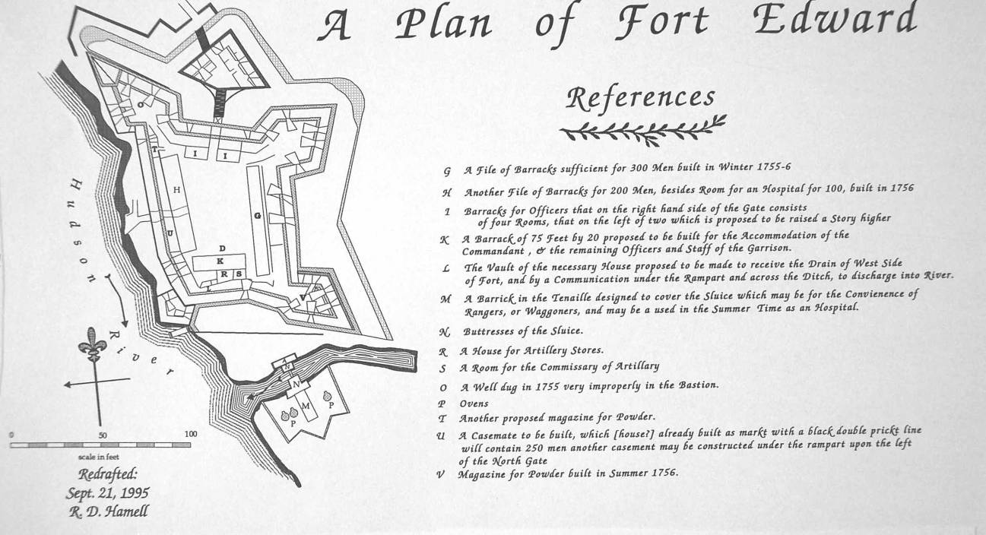

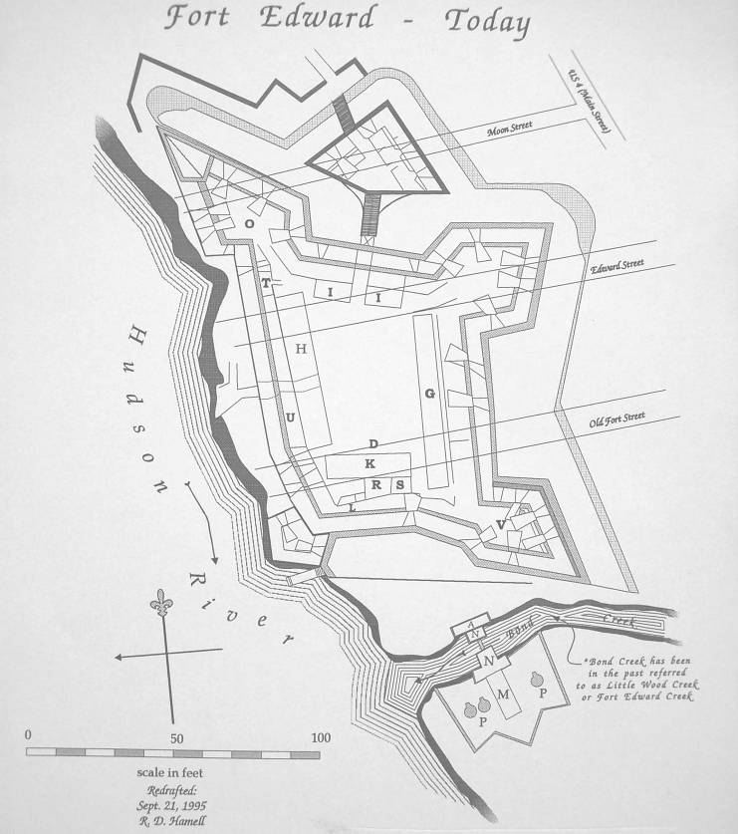

Figure 11 (top). A reconstructed plan of Fort Edward.

Figure 12 (bottom). Fort Edward relative to today's streetscape.

A BRIEF HISTORY OF THE NORTHERN PORTIONS
OF THE CHAMPLAIN CANALS

by Craig Williams

The geographic location of Fort Edward has been a pivoting point in our affairs for much of our documented history and certainly much beyond that. On that pivot is gate that opened economic and cultural opportunities to the north and south via the "Great Carry". At times, the gate swung particularly violently and loudly as during the periodic colonial wars. Most of the time, however, it allowed through people and goods, back and forth, between settlements in the Hudson Valley and those on the Saint Lawrence.
The earliest firm evidence of planning for a canal that would make an easier carry to Whitehall dates from work by Simeon DeWitt, the State's Surveyor-General. In 1790 he drafted a map in preparation for a report to Governor George Clinton on his proposed improvements. He suggested using the natural waterways as much as possible with only a canal between Bond and Wood Creeks, about three miles in length. Three locks, each 50 feet by 10 feet, would be needed. One was positioned on Wood Creek. The other two helped make the climb up from Fort Edward, at "Gilchrist's" (near where Champlain Barge Canal Lock 8 is today) and at "Pettis'" (just north of Dunham's Basin). DeWitt's ideas did not go much further than the report and map.
On a spectrum of significance, the activities of the Northern Inland Lock Navigation Company in the 1790s have always been placed well below the feeble attempts of its counterpart company, the Western Inland Lock Navigation Company. With many of the same people, the Northern Company sought to improve a water route to Lake Champlain. Nothing was completed, really, but the significance of the efforts are should be reconsidered. The Company did come close to a working waterway.
In the summer of 1793 the Northern Company via a private contractor broke ground on a short canal around the west side of the Wood Creek falls in Whitehall, about where Barge Lock 12 is today. Samuel Beman and James McCotten (later, Beman alone) struggled through the rock excavations and attempted to prepare for locks. Unfortunately, natural and human forces were against them. In August 1794 the Company's engineer, Weston, made comments about the adequacy of the Whitehall work that resulted in near stoppage of it. With still hopeful thinking, the Company brought a brickmaker, Joseph Stansbury of New Jersey, to the location in the spring of 1796 to prepare 10-inch by 5-inch by 3-inch brick to line the lock chamber. Much brick was apparently made and some of it may have been laid in the chamber the following year. At that point, information on the work fades from the historical record. Certainly, if the canal and its lock (locks?) at Whitehall were completed, there would have been mention of it, wouldn't there?. Nothing of them shows on the c.1817 Roberdeau map of Whitehall. In their 1796 report on their activities, the Northern Company claimed that the Whitehall canal was nearly finished. They also credited their work on clearing the northern Wood Creek. "Boats are now capable of passing from the falls of Skeensborough to near fort Ann."
The State's new board of Canal Commissioners were probably aware of this work when they reported on their proposals in 1814 for the Erie Canal. "The commissioners cannot leave this branch of the subject without stepping a little out of the road in which they ought strictly to walk, for the purpose of expressing their belief, that the communication long since contemplated, between Lake Champlain and Hudson's river may easily be effected; and, thus, another of those great avenues be opened, which Providence has so well prepared, that little more is left for the state, than merely to will the possession of wealth and power." While the Commissioners are to be commended for this recognition, their view of the Champlain as an easy add-on established a pattern of good intentions that always seemed to play second to the needs of the State's other canals.
Construction work began on the "Ditch" version of the Champlain Canal towards the end of the 1817 season with the Wheeler and Smith contract immediately south of Whitehall. By the end of 1819 the portion from Fort Edward north was probably completed. It may have not been in actual use until the following year. By the end of 1821, the planned navigation was useable as far south as the Saratoga Dam. The appearance of this new navigation was similar to that created a century later with the Champlain Barge Canal. The Hudson was made more useful by being dammed up at Northumberland and near Fort Miller. A land cut brought the canal around Fort Miller and an artificial channel was cut between Fort Edward and Whitehall. The latter used Wood Creek when possible.
Two problems appeared. Despite earlier projections, the summit level was inadequately fed with water. The Fort Edward Feeder was soon constructed, only to be soon replaced with the more plentiful Glens Falls Feeder. The river navigation was "at all times tedious and expensive, and during periods of floods and of high winds, is wholly interrupted." In 1825 the State commenced to complete this missing portion of canal navigation and constructed a channel parallel to the river between Fort Edward and Northumberland. It always seemed to be more difficult than originally thought. The contractors were plagued with expensive rock excavations along this section. Calvin Swain and Oliver Griffin took the contract for the section south from the "old" canal at Fort Edward. They additionally complained that their line of the canal ended up going through "an ancient and totally obscured Burying ground out of which they extracted and subsiquently Intered from twenty five to thirty subjects." The partners noted that they also suffered "from the resistence and threats of owners and ocupants of the ground" along which they worked.
Improvements were attempted and some were completed on the Champlain Canal throughout the 19th-century. The wooden locks were rebuilt of stone and then rebuilt to enlarged dimensions. The State worked at enlarging the prism but was never able, until the Barge Canal, to get all of it done. Short sections that persistently remained only five feet deep through much of the century defeated the value of the deepened and widened section elsewhere and troubled boaters.
The first "dirt" work on the entire State's Barge Canal system began on the Champlain at Fort Miller in April 1905. A portion of the new canal, between Fort Ann and Whitehall, was in use as early as 1910. The length between Northumberland and Whitehall was in use by 1913. Actual completion, however, seemed to drag on. Dredging and other miscellaneous work continued after the official 1918 completion of the system.
As was the case with previous constructions, the State built the Champlain Barge Canal under a system of contracts to private construction firms. A viewing of work on these individual contracts shows the complexity of the more than a decade of efforts that went into the new canal.

Contract 1

The contract was for preparing a dredged channel in the Hudson River between Northumberland and Fort Miller and from Crocker's Reef to Fort Edward. It was awarded to the Empire Engineering Corporation on April 18, 1905 with actual work beginning about August 1, 1905. During the following winter, machinery for the river work such as dredges, tugs, and scows were assembled. The hulls for the dredges were brought to the site via the old Champlain Canal while the actual machinery was delivered by rail. In July 1906 one of the dredges was able to begin excavating in the Hudson. Two dredges worked initially on the contract, the Peconic and the Pontiac. A floating rock breaker helped prepared the channel. Work on the Crocker's Reef Dam started on June 5, 1906 and was finished by November of the following year. By the end of 1909, just over eighty percent of the projected work had been completed.
In June 1910 the contract was "practically complete" and much of the contractor's plant was being dismantled and loaded for shipment to Buffalo. The contractor's tug was sold to another contractor in Fairport. Dredge activity continued into the following year, finishing its work in September 1911.
A separate contract, Barge Canal Contract 1-A, was let in 1914 to complete the channel between south of Fort Edward. Over the next few years, reports were made on the contract that included references to opening a quarry on the west side of the river, laying stone wash wall, and building workers' shanties also on the west side of the river. Even though the contract neared completion in October 1916, work was still underway in March 1918 when shore protection was placed along the Idle Hour camp on Bradley's Island. The contract was canceled in August 1918 under the wartime Walters Act. Work was eventually finished under Barge Canal Contract 194 in 1920.

Contract 3

Sundstrom and Stratton were awarded the contract on April 4, 1905 to excavate and build the just over two miles of artificial channel between Fort Miller and Crocker's Reef. The contract also included Lock 6. The commencement of this contract marked the true "shovel to dirt" beginning of the State's new Barge Canal. On either April 23rd or 24th, 1905, ground was broken "without any of the ceremonies usual to such an occasion."
One of the first projects of the contract was the construction of a temporary channel around the site of Lock 6 in order to maintain navigation on the old canal. The abutments for three of the contract's bridges were finished by July 1907. Preparation of the concrete necessitated the erection of stone and sand bins and a mixing plant. Via canal boats on the old canal, stone came from Northumberland and sand from near Sandy Hill. This contract shared with several other Champlain Canal contracts a perplexing problem with land slides. In the summer of 1908 at least two major slides set back work.
By the summer of 1909, the contract neared completion and construction equipment was being prepared for shipment elsewhere. The contract was formally declared completed the following year.
Three (Fort Miller, Ridge Road, and Payne's Bridge) of the canal bridges along Contract 3 were raised by the Groton Bridge Company of New York State's Tompkins County under Barge Canal Contract 7. Work on erecting the steelwork of the bridges was completed in 1907.
The construction work must have appeared, at least, interesting to local inhabitants. Retired state canal employee and Fort Miller resident, Jim Petit, recalled hearing that "this town was a madhouse... and up above the village here... is a field... there were about 300 Italians camped and they had their own bake oven... and that's where the Italian laborers stayed. None of them could speak English... and when they blasted, rocks would of course fly all over and they had a crew that went around just repairing chimneys and they replastered the church. They knocked all the plaster off that and there's a rock in my attic that come down through the roof... Oh, they said it was wild around here. When they blew the whistle announcing a blast, everybody ran for cover."

Contract 26

Barge Canal Contract 26 encompassed less than a mile of channel dredging between the northern end of Contract 1 and Fort Edward. It was let in March 1908 to the Lake Erie Dredging Company of Buffalo with work truly beginning by that summer. A floating plant consisting of a dredge, two dump scows and a small steam tug came up the old canal to the Moses kill, followed the creek to the river and then continued up to just south of Fort Edward. They started operations in June 1908. Through 1909 the dredges and the tug Puritan continued to work, finishing more that eighty percent of the contract by the end of the year. The contract was formally declared completed in the summer of 1910.

Contract 27/27A

As originally let, the contract included the construction of nearly four miles of prism from Fort Edward north and the construction of Locks 7 and 8 and the Fort Edward Junction Lock. Excavation work began in April 1907 by the Kinser Construction Company. They had been awarded the contract in November of the previous year. Within a lengthy list of tools and equipment that the contractor had soon assembled is a reference to "100 mules and horses with all necessary wagons, scrapers, etc., with four-wheel graders, or wagon loaders".
After nearly a year of substantial work that nearly half completed the contract, Kinser's efforts came to a grinding (sliding?) halt on December 15, 1908. A massive land slide at the original site of Lock 7 created a conflict between the State and Kinser. The company refused to assume responsibility to clear the slide in time to restore navigation for the 1909 season's opening. Department of Public Works forces took over work at the site of the slide with 175 people and 50 teams. An earthen dike was created during the early spring that allowed navigation to resume in May 1909. A pool was thus created over the now-former site of Lock 7. Kinser's equipment, including the dredge Hudson, were dismantled and removed that summer after the cancellation of the contract.
Resumption of the Fort Edward work came with Barge Canal Contract 27A and its awarding to Holler and Shepard in December 1910. Work didn't actually begin until well into the following year. This firm, too, was troubled with landslides. The East Street Bridge and the Hudson Valley Railroad were both victims of slides. The contract was finally completed in March 1915.

Contract 25

As originally designed, the contract was about thirteen miles of canal prism roughly between Comstock and Dunham's Basin. It included the construction of Champlain Barge Lock 9 and 10, yes, 10. A month after the November 1906 awarding of the contract, the Atlantic, Gulf, and Pacific Company began work on site. Almost immediately, the construction of a dredge was started. It was working by April 1907. By the summer of 1908 the hydraulic dredge Fort Edward, "built especially for" the contract, was moving record amounts of material. By the following year it was joined by a dipper dredge that had been built at Comstock. Over half the contract was finished by the end of 1909. It was essentially completed by the end of 1910.

Contract 15

Barge Canal Contract 15 included Locks 11 and 12 with their associated dams and about seven miles of channel from Whitehall south. It was awarded in August 1909 to the Atlantic, Gulf, and Pacific Company. The firm was also to have Contract 25, the next south portion of the canal. The firm began work on October 10, 1906. Work on building a dredge began the following month. Over the next several years, the hydraulic dredge Champlain and the dipper dredge Comstock cleared the new channel. The contract was finished by the end of 1911.

? William Hill, Old Fort Edward (Fort Edward: 1929), p.14.
? James Sullivan, The Papers of Sir William Johnson, (Albany: University of the State of New York, 1921), p.484.
? James Sullivan, The Papers of Sir William Johnson (Albany: University of the State of New York, 1921), p.730.
? James Sullivan, The Papers of Sir William Johnson (Albany: University of the State of New York, 1921), p.883.
? James Sullivan, The Papers of Sir William Johnson (Albany: University of the State of New York, 1921), p.31.
? William Hill, Old Fort Edward (Fort Edward: 1929), p.73.
? E. B. O'Callaghan, Documents Relative to the Colonial History of the State of New York (Albany: Weed, Parsons, and Company, 1858), Volume X, p.332
? Huntington Library, San Marino, California.
? Fitch (1966), p.3; Luke Gridley (edited for the Acorn Club), Luke Gridley's Diary of 1757 While in Service in the French and Indian War (Hartford Press, 1907), p.40.
? New York Historical Society Collections (1881), p.39.
? Huntington Library, San Marino, California.
? Surveyor-General Collection, Map 774, New York State Archives; Elkanah Watson Papers, Box 53, Folder 1, New York State Library.
? Schuyler Papers, New York Public Library; Beman and McCotten to Schuyler, 12 June 1793; Scott and Wheeler to Schuyler, September 18, 1793; Schuyler to Beman, August 15, 1794; Report of the Northern Company, March 11, 1796; Kane to Schuyler, May 21, 1793; Bleecker to Schuyler, September 21, 1797; 1796 Report of the Western and Northern Companies.
? Annual Report of the Canal Commissioners (1814), in Canal Laws, I, p.103.
? Canal Laws, II, p.180; Canal Board Papers, Series A1140, 1828, Packet 12, New York State Archives. For more on local opposition to the State's acquisition and construction techniques for the Ditch Champlain Canal, see Canal Laws, II, p.81-82.
? Barge Canal Bulletin (May 1910), p.168; Annual Report of the Superintendent of Public Works (1917), p.12.
? Annual Report of the State Engineer and Surveyor (1906), Assembly Document 36, p.241; (1907), Assembly Document 19, p.75-76; (1908), Assembly Document 15, p.88; (1909), Assembly Document 27, p.97; Barge Canal Bulletin (January 1910), p.3.
? Barge Canal Bulletin (July 1910), p.301; (October 1911), p.311; (November 1911), p.344.
? Barge Canal Bulletin (October 1914), p.376; (February 1916), p.40; (April 1916), p.102; (July 1916), p.193; (November 1916), p.317; (April 1918), p.116; (September 1918), p.268.
? Annual Report of the State Engineer and Surveyor (1906), Assembly Document 36, p.241; Barge Canal Bulletin (February 1908), p.14; (June 1909), p.225.
? Annual Report of the State Engineer and Surveyor (1908), Assembly Document 15, p.91; Barge Canal Bulletin (February 1908), p.14; (September 1908), p.231.
? Barge Canal Bulletin (May 1909), p.143; (October 1909), p.381; (September 1910), p.381.
? Annual Report of the State Engineer and Surveyor (1908), Assembly Document 15, p.92-93.
? Interview with James Petit, September 3, 1993, New York State Museum.
? Annual Report of the State Engineer and Surveyor (1909), Assembly Document 27, p.105; Barge Canal Bulletin (February 1908), p.15; (April 1908), p.59, 69; (June 1908), p.120; (July 1908), p.153; (January 1909), p.15; (April 1909), p.121; (January 1910), p.3; (September 1910), p.381.
? Annual Report of the State Engineer and Surveyor (1908), Assembly Document 15, p.93; (1909), Assembly Document 27, p.107.
? Annual Report of the State Engineer and Surveyor (1910), Assembly Document 22, p.87-88; Annual Report of the Superintendent of Public Works (1910), Senate Document 20, p.23; Barge Canal Bulletin (February 1908), p.15; (March 1910), p.111; (May 1909), p.168; (June 1909), p.202; (August 1909), p.305.
? Barge Canal Bulletin (March 1911), p.94; (May 1911), p.153; (September 1911), p.280; (October 1912), p.322; (April 1913), p.135; (April 1915), p.113.
? Annual Report of the State Engineer and Surveyor (1908), Assembly Document 15, p.95; Barge Canal Bulletin (February 1908), p.15; (June 1908), p.111; (October 1908), p.274; (May 1909), p.168; (February 1910), p.75; (January 1912), p.20.
? Annual Report of the State Engineer and Surveyor (1908), Assembly Document 15, p.94; Barge Canal Bulletin (May 1908), p.87; (June 1908), p.111; (July 1908), p.154; (March 1909), p.86; (April 1909), p.121; (May 1909), p.169; (December 1909), p.468; (May 1910), p.188; (January 1912), p.22.

