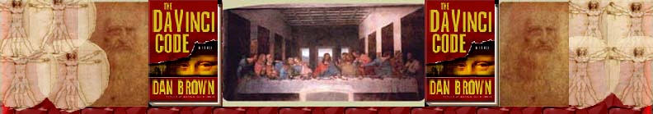Chapter 94
Jay Dolan

St. James’s Park
Resident Pelicans
Westminster
Buckingham
King Henry VIII
Charles II
Big Ben
Cognac
Orb
Biggin Hill Executive Airport
Scotland Yard

St. James’s Park It is the oldest Royal Park in London. The three palaces that surround in are Westminster (Houses of Parliament), St. James’s Palace, and Buckingham Palace. The park used to be a marshy “watermeadow.” During the thirteenth century a leper hospital was built there and the park adopted its name from that hospital. In 1532 Henry VIII built St. James’s Palace. James I made the road that runs in front of the palace, and Charles II made lots of changes by designing avenues and planting trees. There are also pelicans that live there.
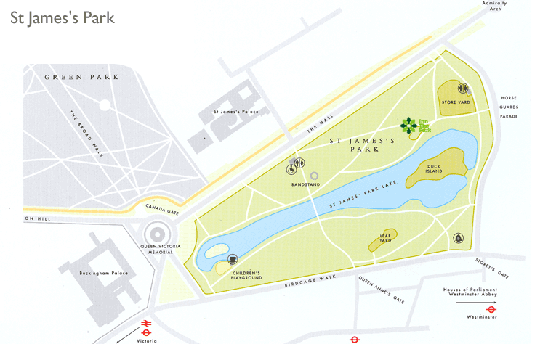

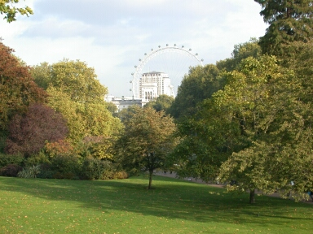
http://www.photoguide.to/london/stjamespark.html
http://www.royalparks.gov.uk/parks/st_james_park/
http://www.royalparks.gov.uk/parks/st_james_park/history.cfm

Resident Pelicans There are many pelicans in the Park. They are all descendants from the two which were originally a present from the Russian Ambassador in the 1660s.
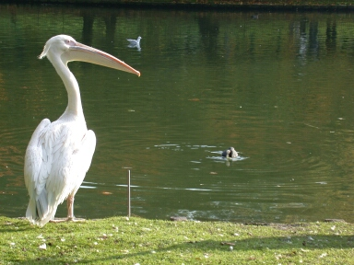
http://www.photoguide.to/london/stjamespark.html
http://www.glasgowzoo.co.uk/articles/birds/pelicans.php

Westminster (Houses of Parliament)- After being consumed by fire in 1834, Charles Barry designed what is now the Houses of Parliament in London. They were built in the Gothic style in 1837 and finished in 1860. The Commons chamber was bombed during WWII, but was restored and reopened in 1950. Westminster holds the House of Lords and the House of Commons. There are also three towers. They are called Victoria Tower, St. Stephen’s Tower, and the famous clock-tower Big Ben.
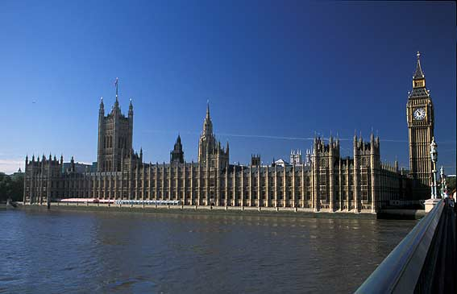
http://www.jorgetutor.com/greatbritain/inglaterra/se/westminster/westminster4.jpg
http://search.eb.com/eb/article?tocId=9058524&query=Westminster%20Palace&ct=

Buckingham Palace This Palace serves as the residence of the British sovereign. The original building was built in 1705.George III bought the house in 1762 for his wife, Queen Charlotte. It then became known as the Queen’s house. In the 1820s, George IV ordered the conversion of the house into a palace.
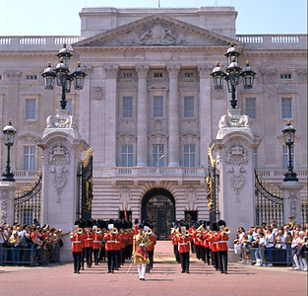
http://search.eb.com/eb/article?tocId=9017892&query=Westminster%20Palace&ct=

King Henry VIII He reigned as the King of England from 1509-1547. He reigned during the beginnings of the English Renaissance and the English Reformation. He had six wives. He was obsessed with the idea of having a son and when his wives could not produce a male child he would divorce them or execute them. His divorce from his first wife was the reason for the English Reformation. His new Christianity kept most of the principals of Roman Catholicism; however, it allowed marriages to be annulled. The church was called The Church of England or the Anglican Church.
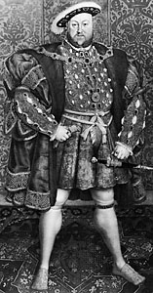
http://search.eb.com/eb/article?tocId=3129

Charles II- He was the king of Great Britain and Ireland from 1660- 1685. He was exiled during the Puritan Commonwealth but was restored to the throne. The years during his reign are known as the Restoration period. He was able to lead the country through controversy between Catholics, Anglicans, and dissenters.
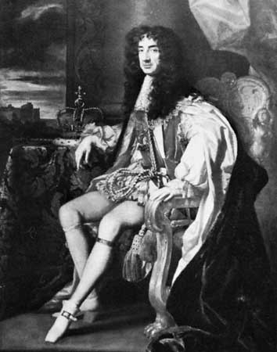
http://search.eb.com/eb/article?tocId=9022560&query=Charles%20II&ct=

Big Ben In October of 1834, the palace of Westminster was destroyed by fire. After it was destroyed, there was a contest to see who could come up with a design suitable for the new palace. Charles Barry was the man who won the contest and his design used a clock-tower which would be thirty feet in diameter. At the time it was the largest clock in the world. The clockmaker was named Edward John Dent. After many difficulties, the Big Ben was completed in 1862. It wasn’t until 1976 that major restoration was needed on the clock-tower after the mechanisms inside broke and caused severe damage.
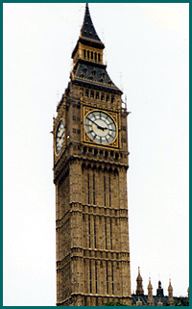
http://www.ngsgenealogy.org/images/big.ben.jpg
http://www.bigben.freeservers.com/history.html

Cognac- “A French brandy of superior quality distilled from Cognac wine. The name is sometimes extended (for trade purposes) to any French brandy.”
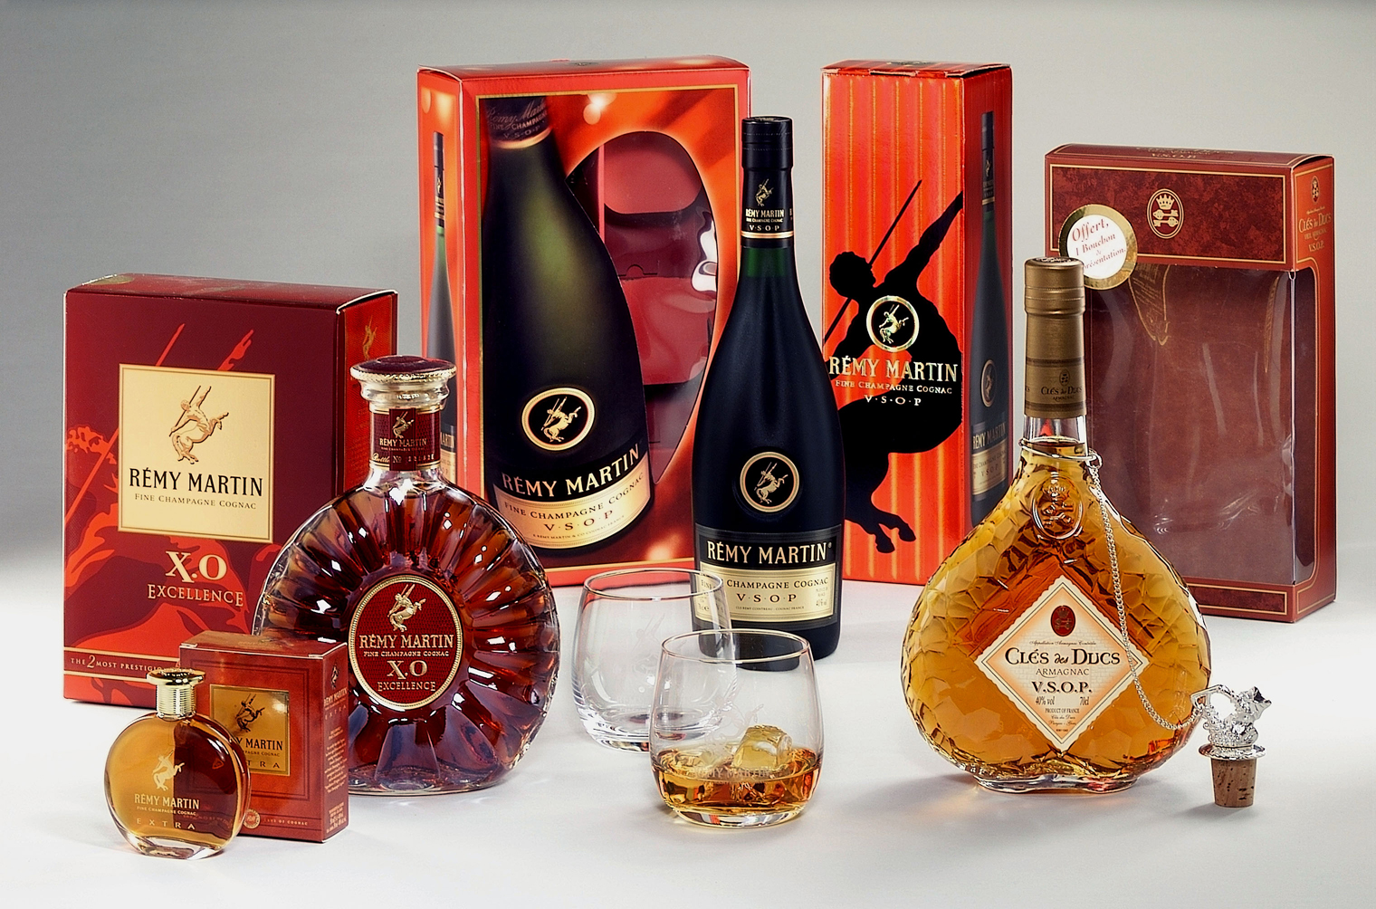
http://www.maxxium.at/presse/images/geschenke_remy_cdd.jpg
http://dictionary.oed.com/cgi/entry/00043383?single=1&query_type=word&queryword=Cognac&edition=2e&first=1&max_to_show=10

Orb See Chapter 74

Biggin Hill Executive Airport- Founded in 1917, Biggin Airport used to serve as a front line RAF (Royal Air Force) station which housed squadrons of fighter jets. Today, it serves as South London’s local airport. A plane can be chartered there to anywhere in the world. It is, “an ideal point of arrival for business visitors to London and 'home base' for many corporate, private and charter aircraft owners, it is a thriving business centre with great scope to grow.”
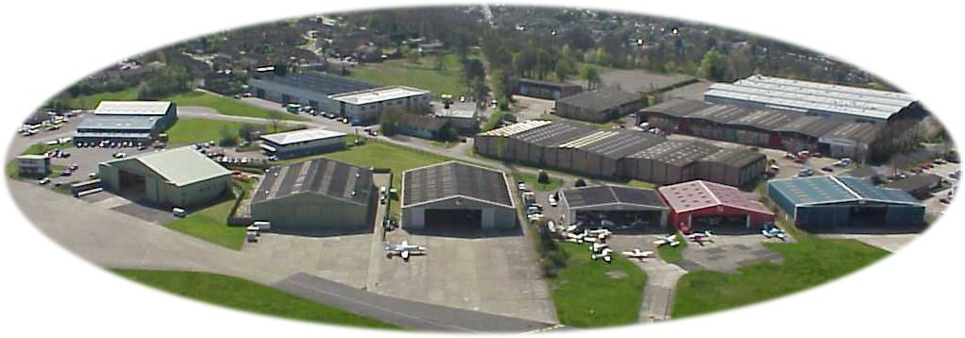
http://www.bigginhillairport.com/home.htm
http://www.bigginhillairport.com/Property.htm

Scotland Yard It is the headquarters for London’s Metropolitan Police. Located in the borough of Westminster, south of St. James’s Park, London’s police force was created in 1829. Sir Robert Peel, the home secretary at the time, introduced it in Parliament. That is why the policemen are called “bobbies” and “peelers.” These policemen replaced the old system of watchmen. Scotland Yard got its name because it stands on the site of a medieval palace that used to house Scottish Royalty when they visited London. The headquarters has changed locations twice since its founding. In 1890 it moved to a new building on the Thames Embankment. It moved again in 1967 at the corner or Victoria Street and Broadway. It was also called New Scotland Yard.
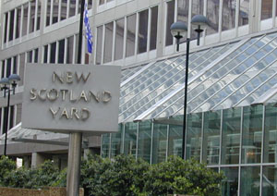
http://as.wn.com/i/b7/173a2dbb31a32e.jpg
http://search.eb.com/eb/article?tocId=9066349&query=Scotland%20Yard&ct=

