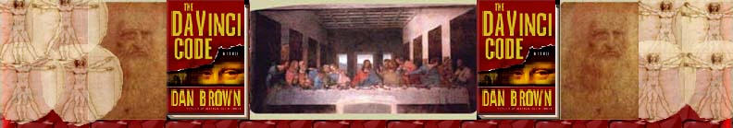Chapter 43
Angie Todd

Bank of Zurich
L'lle Saint-Louis
Cognoscenti
Bordeaux
Fragonard
Boucher
Quartier Latin
Maasai warriors
15-euro-per-hour
Geldschrank bank
fleur-de-lis seal
Sangreal
Oui
La Police? Si rapidement?

Bank of Zurich See Chapter 40.

L'lle Saint-Louis A street parallel to the Seine river in Paris. This road is noted for its beautiful scenery, antique buildings, museums, theaters, as well as a few expensive riverside apartments.

L’lle Saint-Louis

Cognoscenti See Chapter 37.

Bordeaux is the largest fine wine-making region in the world — with 284,320 acres of A.O.C. vines — as well as the most legendary. Its sterling reputation is built mostly on red wines, especially those from the Médoc, Saint-Emilion, Pomerol and the famous Sauternes (sweet white) districts. But Bordeaux doesn't just mean reds. The region also produces a wide range of other excellent wines, including dry and sweet whites, rosé and clairet, and a sparkling wine called Crémant de Bordeaux.
The World's Leading Fine Wine-Producing Region
Bordeaux was geographically predestined to produce the world's finest wines. The region has an ideal climate — moderated by the Gulf Stream, tempered by the Atlantic Ocean, with the tallest sand dunes in Europe and the forest of the Landes providing a natural wind barrier protecting the vineyards. The great diversity of microclimates and soils (clay, gravel, chalk, limestone) are ideally suited to Bordeaux's different grape varieties:
- Reds: Cabernet Sauvignon, Cabernet Franc, Merlot
- Whites: Sauvignon Blanc, Sémillon and Muscadelle
The Bordeaux Blend
The richness and elegance of Bordeaux wines is the result of subtle blending of these different grape varieties, combined with centuries of experience, the skills of local winemakers and on-going research by oenologists (wine scientists) and technicians. (http://www.bordeaux.com/)

Fragonard Jean-Honore Fragonard (1732-1806) a French Rococo painter who studied under Boucher (see below). He generally painted landscapes, the French court, and contemporary pieces. Two of his pieces are on presentation at the Louvre while most of his other’s reside in private collections. (More on Fragonard: http://www.biography.com/search/article.jsp?aid=9300205&search=fragonard)

Jean-Honore Fragonard’s The Swing.

Boucher Francois Boucher (1703-1770), a French painter, considered to be the leading Rococo artist of the era. He focused his attention on portraits of Madame de Pompadour but also worked on stage design and tapestries as well. Boucher, along with his pupil Fragonard, was considered to be “wholly representative of the frivolous spirit of his age,” (biography.com, http://www.biography.com/search/article.jsp?aid=9221016&search=Boucher)
Boucher’s The Rape of Europa

Quartier Latin “Latin Quarter” of Paris. This part of Paris got its name because students attending the university primarily spoke Latin. If you were to walk down the streets of Quartier Latin today, you would most likely hear Greek than Latin. This district is filled with antique shops and Greek restaurants with proprietors trying to bring in business. Many tourists flock to this part of Paris because here, they can get a feel of what Greece is like without ever setting foot in the country. http://www.atkielski.com/inlink.php?/PhotoGallery/Paris/General/RueDeLaHarpeSmall.html)
Rue de la Harpe in the Quartier Latin.

Rue de la Huchette in the heart of the Quartier Latin.

Maasai warriors The Maasai are nomadic herders who reside mostly in Kenya and Tanzania. This tribe is very popular among the media due to their ritual of drinking the blood of a bull to survive. I was unable to find any information on the internet of the Maasai warriors’ ability to wake from a deep sleep to a state of battle-readiness in seconds; however, I sent an e-mail to the Maasai Association and haven’t heard back yet. (Information from http://www.maasai-infoline.org/ and www.Britannica.com)

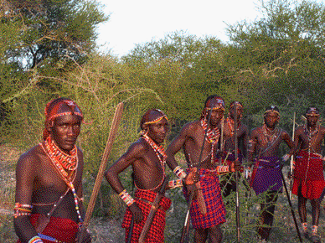
Maasai warriors

15-euro-per-hour Converts to about $19.00 United States Dollars. In Quebec, the average, unexperienced watchman earns $15.62 US Dollars or $12.73 Euros. If the watchman working at the Zurich Bank made 15 euros an hour, he is actually making a lot more money than a watchman in Quebec. (http://www.ccq.org/eng/publications/conventions_collectives/sal_rates_residential_28dec_2003.PDF October 3, 2004)

Geldschrank bank ‘Geldschrank’ is a German word meaning safe or moneybox. A Geldschrank bank provides anonymity and safety by using, more often than not, a 10-digit code and a key. Transactions are made without the presence of any security officer or observer of any type and there are no master keys to the safe. If you forget your number or lost your key, you are “out of luck”!! (Info from http://www.larry-adams.com/0403_article.htm)

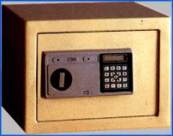

fleur-de-lis seal The origin of the fleur-de-lis seal is unknown but there are a few theories. The most commonly accepted theory is that the fleur-de-lis is a symbol of the Virgin Mary. There is similarity among the seal, the trefoil, the shamrock and other tripartite forms that Christians associate with the Trinity. The fleur-de-lis is representative of purity and the Trinity, which supports the notion that it is also a symbol of the Virgin Mary. Interestingly enough, the fleur-de-lis is also the symbol for the Boy Scouts and the Priory of Sion.


Sangreal Grail. In a biblical legend, the grail was used by Jesus at the Last Supper and by Joseph of Arimathea to collect blood from the Savior on the cross. Finding this cup was the objective of a mystical quest pursued by the Knights of the Round Table as well as many other societies. (Encyclopedia Britannica: http://www.britannica.com/ebc/article?tocId=9365933&query=grail&ct=, Oxford English Dictionary: http://dictionary.oed.com/cgi/entry/00097555?query_type=misspelling&queryword=sangreal&edition=2e&first=1&max_to_show=10&xref=1&single=1&sort_type=alpha) The picture below is claimed by the Rosslyn Templars to be the Holy Grail. Those of you who have seen Indiana Jones: The Last Crusade would envision the Holy Grail to be nothing more than a simple cup but many believe it is very gaudy like this one. (It is actually a very interesting idea that the sangreal has been found. To learn more, visit
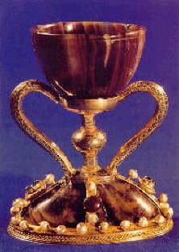
http://www.rosslyntemplars.org.uk/holy_grail.htm)

Oui- French for "Yes"
La Police? Si rapidement?- French for "The Police? So quickly?"

