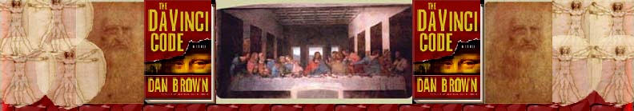Chapter 32
Jeff Murphy

Tuileries Gardens
SmartCar
La Pyramide Inversée
Rue de Rivoli
Champs-Elysees
Fifth Avenue of Paris
Madonna of the Rocks
Confraternity of the Immaculate Conception
Virgin Mary
John the Baptist
Uriel
London’s National Gallery
Virgin of the Rocks
Fleur-de-lis
Hotel de Crillon
Charles de Gaulle Airport
Normandy
Creully
Aubusson tapestry
Grotto
Gossamer gowns
Avenue Gabriel

Tuileries Gardens See earlier.

SmartCar “Size matters. Only eight feet long, the efficient Smart Car challenges habits of personal mobility. It is especially well suited to urban environments. As suggested by its clever marketing slogan "reduced to the max," the Smart Car has been developed to maximize the convenience, comfort, and safety of driver and passenger, while minimizing the impact on the environment. Low fuel consumption (averaging 49 miles per gallon) and eco-friendly methods of production distinguish the car from others on the market.
The Smart Car was developed in the early 1990s by Mercedes-Benz. A team of engineers and designers led by Gerhard Steinle created the prototype in southern California. The design was further developed with input from the Swatch watch company. Cars are sold at "Smart Centers" throughout Europe, where the brightly colored vehicles are stacked in towers like objects in a display case, clearly aimed at youthful, style-conscious consumers seeking an affordable car. Since their debut in 1998, nearly half a million Smart Cars have been produced, and they have become a common sight in Europe—sometimes two per conventional parking space.”
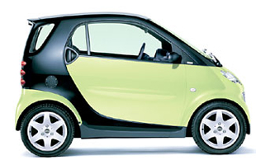
http://www.moma.org/exhibitions/2002/autobodies/smartcar.html4 Oct. 2004

La Pyramide Inversée – “Architects Pei, Cobb Freed and Partners created a 'Pyramide Inversee' of laminated glass to bring light down to the Louvre's new underground complex and mark the intersection of two main walkways, orienting visitors towards the museum entrance. The Inverted Pyramid forms part of the Phase II government renovation of the most famous museum in Paris.
All but invisible above ground, the Invested Pyramid uses a frieze of spotlights and mirrors to animate the structure after dark. At dusk, the structure makes an ethereal transition between day and night. It also serves effectively as a monumental chandelier.”
(see chapter 3 and 4 annotations)
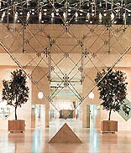
“‘Pyramide Inversee’ of laminated glass brings light down to the Louvre’s new underground complex”
http://www.dupont.com/safetyglass/lgn/stories/0409.html, 4 Oct. 2004

Rue de Rivoli See Chapter 17.

Champs-Elysees “officially Avenue des Champs-élysées (French: “Avenue of the Elysian Fields”) Champs-Elysees is a broad avenue in Paris, one of the world's most famous, which stretches 1.17 miles (1.88 km) from the Arc de Triomphe to the Place de la Concorde. It is divided into two parts by the Rond-Point (“roundabout”) des Champs-Élysées. The lower part, toward the Place de la Concorde (and beyond, the Tuileries Gardens), is surrounded by gardens, museums, theatres, and a few restaurants. The upper part, toward the Arc de Triomphe, was traditionally the site of luxury shops and hotels, restaurants and pavement cafés, theatres, banks, and offices but, since World War II, has steadily declined, becoming the scene of fast-food restaurants, garish movie houses, souvenir vendors, sidewalk hawkers, airline offices, and shopping malls. When first designed in the 17th century, the Champs-Élysées consisted of fields, an open area then on the outskirts of Paris, containing the Cours de la Reine (“Queen's Drive”), an approach road running along the Seine River to the Tuileries Palace. Later in the same century, André Le Nôtre landscaped the broad, shady avenue and extended it to the crest of the hill on which the Arc de Triomphe now stands. In the 18th century the whole came to be called the Champs-Élysées. The Arc de Triomphe was inaugurated in 1836, and by the 1860s, when Baron Georges-Eugène Haussmann was grandly redrawing the boulevards of Paris, the Champs-Élysées had become a prestigious thoroughfare of palaces, hotels, and restaurants.” See Chapter 25. Encyclopædia Britannica. 2004. Encyclopædia Britannica Online. 3 Oct. 2004 <http://search.eb.com/eb/article?tocId=9022366>.

Fifth Avenue of Paris – Dan Brown compares Champs-Elysées to Fifth Avenue in New York City. Fifth Avenue is a street in Manhattan that is lined with famous elegant and expensive stores. Fifth Avenue runs from Washington Square Park, past Central Park, and into Harlem.
“New York City Tourism” http://www.nyctourist.com/ 4 Oct. 2004

Madonna of the Rocks See Chapter 30.

Confraternity of the Immaculate Conception – “The Confraternity of the Immaculate Conception of the Most Blessed Virgin Mary exists to promote the Blue Scapular of the Immaculate Conception so that Mary Immaculate's motherly love might strengthen, comfort, and fill hearts with the joy whose source is her Son, Jesus Christ.
Confraternities were established in the Middle Ages when many lay people wished to participate in some way in the spiritual life of religious orders. The sign of acceptance was the investing of a scapular to identify its members.” The doctrine of the Immacualte Conception, that May was born without Original Sin is confused by many with the “Virgin Birth,” i.e. that Mary conceived Jesus without intercourse.

“Marian Fathers: Confraternity & Our Lady’s Blue Scapular” http://www.padrimariani.org/confraternity.html 4 Oct. 2004

Virgin Mary “the mother of Jesus, an object of veneration in the Christian church since the apostolic age, and a favourite subject in Western art, music, and literature. Mary is known from biblical references, which are, however, too sparse to construct a coherent biography. The development of the doctrine of Mary can be traced through titles that have been ascribed to her in the history of the Christian communions—guarantee of the incarnation, virgin mother, second Eve, mother of God, ever virgin, immaculate, and assumed into heaven. Her humility and obedience to the message of God have made her an exemplar for all ages of Christians. Out of the details supplied in the New Testament by the Gospels about the maid of Galilee, Christian piety and theology have constructed a picture of Mary that fulfills the prediction ascribed to her in the Magnificat (Luke 1:48): “Henceforth all generations will call me blessed.” Encyclopædia Britannica. 2004. Encyclopædia Britannica Online. 3 Oct. 2004 <http://search.eb.com/eb/article?tocId=9051208>

John the Baptist “Jewish prophet of priestly origin who preached the imminence of God's Final Judgment and baptized those who repented in self-preparation for it; he is revered in the Christian Church as the forerunner of Jesus Christ. After a period of desert solitude, he attained notice as a prophet in the region of the lower Jordan Valley. He had a circle of disciples, and Jesus was among the recipients of his rite of baptism.” Encyclopædia Britannica. 2004. Encyclopædia Britannica Online.
3 Oct. 2004 <http://search.eb.com/eb/article?tocId=9043819>.

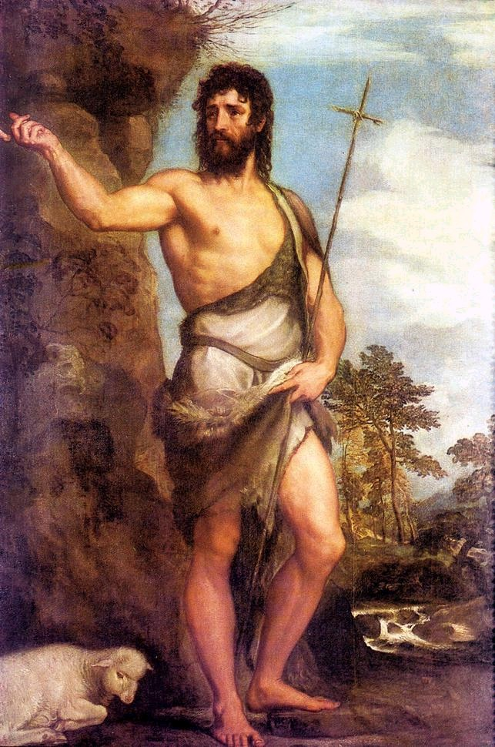
http://campus.queens.edu/depts/history/Syllabi/Italy%20IEP/HO%20Titian%20Links%20Page.htm 12/2/04

Uriel See Chapter 30.

London’s National Gallery “art museum in London that houses Great Britain's national collection of European paintings. It is located on the north side of Trafalgar Square, Westminster.
The National Gallery was founded in 1824 when the British government bought a collection of 38 paintings from the estate of the merchant John Julius Angerstein (1735–1823). The collection was initially exhibited in Angerstein's house at 100 Pall Mall, but in 1838 it was reopened to the public in its current premises. This Neoclassical structure, designed by the Greek Revival architect William Wilkins, was enlarged in 1860, 1876, 1886, and 1975 and in 1991 with the addition of the Sainsbury Wing, by the American architect Robert Venturi. Until the opening of the Tate Gallery in 1897, modern British art was also displayed at the National Gallery. Since 1856 the National Gallery also has had responsibility for the historical portraits housed in the National Portrait Gallery.
The collection now comprises only some 2,000 works, but it is regarded by many as the most representative sampling of European painting in the world. It has the most comprehensive collection of Italian Renaissance paintings outside Italy, with works by most of the great Florentine and Venetian masters of that period. There are also impressive holdings of works by various British, Dutch, French, Spanish, and Flemish painters from the 15th to the 19th century. Among the artists represented are Leonardo, Raphael, and Vermeer. The museum's small collection of French Impressionist and Postimpressionist paintings is notable, and most of the works are exhibited.”
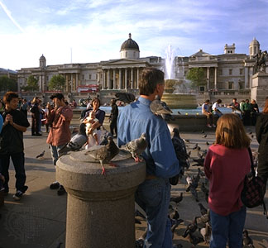
Encyclopædia Britannica. 2004. Encyclopædia Britannica Online. 3 Oct. 2004 <http://search.eb.com/eb/article?tocId=9054977>.

Virgin of the Rocks “its first version (1483–86) is the work that reveals Leonardo's painting at its purest. It depicts the apocryphal legend of the meeting in the wilderness between the young John the Baptist and Jesus returning home from Egypt. The secret of the picture's effect lies in Leonardo's use of every means at his disposal to emphasize the visionary nature of the scene: the soft colour tones (through sfumato), the dim light of the cave from which the figures emerge bathed in light, their quiet attitude, the meaningful gesture with which the angel (the only figure facing the viewer) points to John as the intercessor between the Son of God and humanity—all this combines, in a patterned and formal way, to create a moving and highly expressive work of art.”
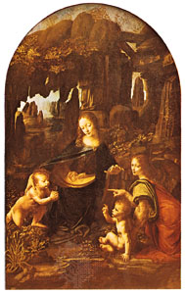
Encyclopædia Britannica. 2004. Encyclopædia Britannica Online.
3 Oct. 2004 <http://search.eb.com/eb/article?tocId=59101>.

Fleur-de-lis See Chapter 22.

Hotel de Crillon This five star hotel “is on the Place de la Concorde, a block from the Tuileries and Champs-Elysées, two blocks from Place Vendôme, and one kilometer from the Louvre. Renovated in 2003, the 147 lavish guestrooms and suites retain a Louis XV style, adding modern amenities such as high-speed Internet access and phones with voice mail.” See the hotel’s website at www.crillon.com

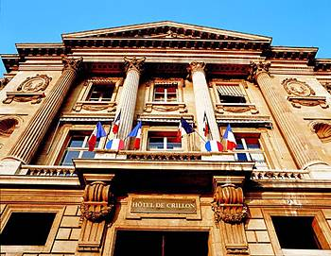
http://www.expedia.com 6 Oct 2004 www.mapquest.fr 12/2/04

Charles de Gaulle Airport “Paris Roissy Charles de Gaulle Airport, 23 kilometres (14 miles) north-east of Paris, is the city's largest airport and was one of the first airports in Europe to have an integrated train system serving it. The RER rapid TGV train service reaches central Paris in approximately 45 minutes, Disney World in ten minutes and Lille and Brussels in an hour.”
“The airport has three terminals that are connected by free shuttle buses and handle over 200,000 passengers and more than 6000 tons of baggage and freight daily. Terminal 1 handles international flights, excluding Air France, Terminal 2 Air France and other airlines flying to European destinations and Terminal T9 handles charter flights exclusively. Terminal 2 currently has five separate halls and is being further expanded to an eventual capacity for 50 million people by 2010.” http://paris-cdg.com/ 6 Oct. 2004

www.mapquest.fr 12/2/04

Normandy “historic and cultural region encompassing the northern French départements of Manche, Calvados, Orne, Eure, and Seine-Maritime and coextensive with the former province of Normandy.” Encyclopædia Britannica. 2004. Encyclopædia Britannica Online. 3 Oct. 2004 <http://search.eb.com/eb/article?tocId=9056144>

Creully A town in Normandy. The D-Day invasion occurred not far from Creully.

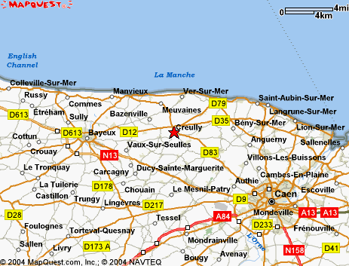
www.mapquest.com 6 Oct 2004

Aubusson tapestry The town of Aubusson in France is famous for its tapestries. See http://www.aubusson-tapestries.com/. Named The Charms of the country life the Aubusson tapestry below is by Boucher in the 18th century. It hangs in the Louvre museum. “Silk screened on Penelope canvas. Kit with wools from Aubusson and "Medicis" of DMC and a plated Gold needle.”

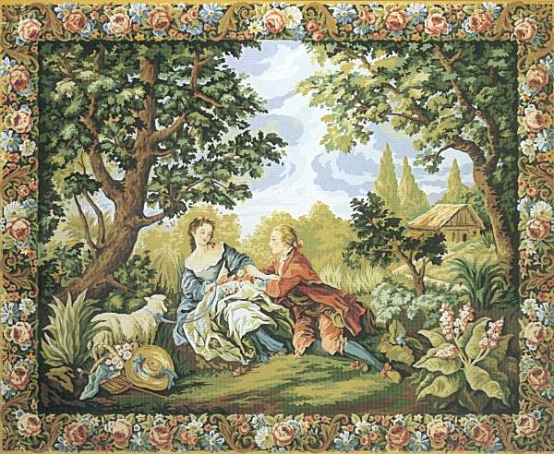
http://www.anniebouquet.tapisseriedefrance.com/bq022.boucher.lebrun.us.htm
6 Oct 2004
Grotto A grotto is “a coarse chamber that appeared to have been hollowed from the granite of the hillside.” (Brown, 142) It is defined as a cave or cavern or an artificial cavernlike recess or structure. Random House Unabridged Dictionary.
© 1997 by Random House, Inc., on Infoplease, http://www.infoplease.com/ipd/A0464506.html,.02 Dec. 2004

Gossamer gowns From Chapter 74. [ME. gos(e)somer(e, app. f. GOOSE n. + SUMMER n. Cf. the synonymous Eng. dial. summer-goose (Craven), summer-colt, G. mädchensommer (lit. ‘girls' summer’), altweibersommer (‘old women's summer’); also G. sommerfäden, Du. zomerdraden, Sw. sommartråd, all literally ‘summer thread’.
The reason for the appellation is somewhat obscure. It is usually assumed that goose in this compound refers to the ‘downy’ appearance of gossamer. But it is to be noted that G. mädchen-, altweibersommer mean not only ‘gossamer’, but also a summer-like period in late autumn, a St. Martin's summer; that the obs. Sc. GO-SUMMER had the latter meaning; and that it is in the warm periods of autumn that gossamer is chiefly observed. These considerations suggest the possibility that the word may primarily have denoted a ‘St. Martin's summer’ (the time when geese were supposed to be in season: cf. G. Gänsemonat ‘geese-month’, November), and have been hence transferred to the characteristic phenomenon of the period. On this view summer-goose (which by etymologizing perversion appears also as summer-gauze) would be a transposition.] 1. A fine filmy substance, consisting of cobwebs, spun by small spiders, which is seen floating in the air in calm weather, esp. in autumn, or spread over a grassy surface: occas. with a and pl., a thread or web of gossamer.
c1325 Gloss. W. de Biblesw. in Wright Voc. 147 Filaundre [glossed] gosesomer. c1386 CHAUCER Sqr.'s T. 251 On ebbe on flood on gossomer and on myst.2. An extremely delicate kind of gauze. 1872 BLACK Adv. Phaeton i. 2 A dress of blue, with touches of white gossamer and fur about the tight wrists and neck. Oxford English Dictionary Online © Oxford University Press 2004
A gossamer gown, therefore, is a nightgown composed of light, airy, gauze material similar to the gossamer of spider webs. Amazon.com describes a typical gossamer gown as a “Whisper weight gauze….to make you look as beautiful as you'll feel. A gown for soft autumn nights and sweet autumn dreams.”

http://www.amazon.com/exec/obidos/tg/detail/-/B00024L1P2/103-8849133-1746249?v=glance, 21 Oct. 2004.

Avenue Gabriel A major road in Paris that runs parallel to the Champs-Elysées.

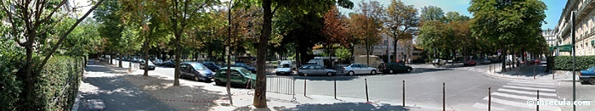
“Avenue Gabriel” http://www.insecula.com/us/salle/MS02400.html 6 Oct 2004

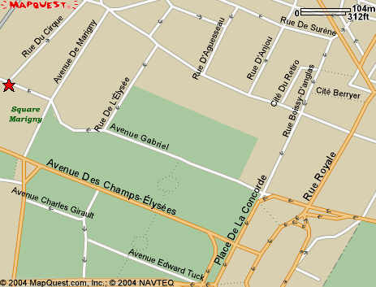
www.mapquest.com 6 Oct 2004

